Carmen Gagnon
Catalyste+ Advisor - voyagine@hotmail.com
For the period of 2023 to 2025

Digital Marketing Plan
COMPANY

Content
Introduction 4
1. Plan 5
Organization profile 5
Project Team 5
Strategy 6
Training 6
Costs and investments 6
Timeframe 7
2. Brand 8
Logos 8
Colors and Fonts 8
Header 8
3. Build 9
Build a website 9
Structure of the website 9
Hosting, domain and technology 9
Optimize the Search Engine 10
Searching for keywords 10
Landing page 14
Videos and pictures 14
Responsive Design – Mobile 15
Get Noticed Locally 17
Google My Business 17
Build on social Media 18
Facebook 19
YouTube 20
Advertise on different platforms 20
Paid Advertising 20
Newsletter 21
Inscription to the NewsLetter 21
List of Subscribers 21
How to build NewsLetter 21
4. Measure 23
Register with Google Analytics 23
Send Sitemap to Google Search Console 23
How to Use Google Analytic 24
Acquisition – How people find your website 24
Engagement - What people do when they’re on your website 25
Demographic – Who is visiting your website 25
Technology – How they visit your website 26
Analytics in YouTube 26
Analytics Facebook Page 27
5. Maintain 28
Administration of the SHOP 28
Online shopping for the client 28
Following the orders 29
Order Statuses 30
Order Completed 30
Reports and customers 31
Editing the products 31
Shipping Settings 33
Payments Settings 34
Promoting your content 34
Content calendar 34
Keep your website Blog alive 35
Posting in Social Media 35
Website Maintenance 39
Appendix 1: Access 40
Gmail and Google Account 40
Hosting and Domain 40
Website WordPress 40
Google tools 40
Facebook 40
YouTube 40
How to add another account to gmail 41

Introduction

It’s clear that in today’s digital world, the first place the average consumer looks for what they want stands online. If you have no presence on the web at all, you won’t be found, and you can’t compete. If a potential customer can’t find you online, they may even conclude that your business doesn’t appear to be legitimate.
All good reasons to develop a Digital Marketing Plan for COMPANY. You will find in the next sections, all the details about the work done by your advisor to improve your presence on the web and how to maintain the achievements. The first step and probably the most important is to identify the team responsible for carrying out the plan. The plan spreads over a few years and will require regular monitoring.
Turning your plan into regular action will help you to take advantage of the digital world.

Plan

Organization profile
Name of organization:
Brand:
Type of organization:

Vision

Mission

Values

Project Team
From COMPANY
From the Department of ….
From catalyste, to start the plan:
- – Country Representative
- – Project Officer
- – Catalyste Advisor for Website and Digital Marketing
I would recommend that xxx will have time dedicated to the maintenance of the plan in her weekly schedule.

Strategy
The strategy for COMPANY
- Build E-Commerce website for selling the products online. A transfer to the bank or COD will be offered. Presentation of COMPANY with all the services to be offered.
- Branding: Improve header for website and social media. Improve pictures of products.
- Optimization of the search engine in the website for a better ranking
- Get noticed locally with Google My Business, Google Map
- Digital Marketing introduction to the team
- Social Media integration with the website
- Administration of the online store
- Launching of the website with Social Media
- Measuring the web presence

Training
Training | Number of employees
 | Description of the training | Proposed
 |  | 2023 | 2024 | After Pandemic
Website Maintenance | Administration of the online store. Updates WordPress | 2 | 2
Digital Marketing | Introduction with the plan | 2 | 2
Social Media | Facebook – YouTube |  | 2 | 2
Google | Google My Business  Google Analytics basics |  | 2 | 2
Storytelling | For Social Media campaign |  |  | 2
Branding | Creation of Pamphlets, Flyers |  |  | 2
NewsLetter | How to build NewsLetter |  |  | 2

Costs and investments
Activities | Investment
 | 2023 | 2024 | 2025
Web Hosting and Domain  - 3-year plan + 1 year domain  - Domain renewal | 150$ US | 15$ US | 15$ US
Training
- Website maintenance
- Production of content for social media – NewsLetter, etc.

Timeframe

Tasks | 2023 |  |  | 2024
 | October 15 | November | December | January | February
Planning
Web Questionnaire
Hosting and Domain
Build Website
Branding
List of Products and conditions
Training Woo Commerce
Intro Digital Marketing
Optimization Search Engine
Google My Business
Get noticed locally
Social Media Facebook
Social Media YouTube
Google Analytic

Brand
A branding and graphic designer was included in the project for COMPANY. It helps to give a direction to the website, optimize the images and to prepare some headers that will be used in the Digital Marketing Strategy.

Logos

Colors and Fonts

Header

Build

Build a website
The main objective of the website is to sell the products online. However, it will not be possible to pay online under the conditions of the country which does not facilitate this method of payment. Payment by bank transfer or cash on delivery will be mentioned. To access the website as an administrator, you will find the code and password in Appendix 1.

Structure of the website
The website https://www.COMPANY.com is divided in 6 main pages:
- Home: Presenting the products in general, buttons to the Shop, conditions, customers review and last articles of the blog.
- About us: Introduction of COMPANY, vision and mission, short video presenting COMPANY and services
- Shop: Divided in categories of products. This is where the customers will shop. Woo Commerce plugin is used for the customer account, cart, command, wish list and message to the customers.
- Blog: Can be used to present new products or events related to COMPANY
- Gallery: Pictures for COMPANY
- Contact: All the information to contact the cooperative
- Footer on every page: Links to Social media, Newsletter subscribe, how to contact

Hosting, domain and technology
The domain and hosting is with Hostgator. For new customers, the price is very competitive if you sign for 3 years. To access the host, you must log with the code provided in Appendix 1.
The domain is https://www.COMPANY.com
The website is set up with WordPress. An admin code allows the user to update the website.
- Theme: Ocean WP with some plugins to improve the appearance and the woo commerce facilities
- WooCommerce: for the shop
- Gutentor: as a page builder
- Contact Form 7: for the contact page
- Newsletter: For subscribe and eventually development of a Newsletter

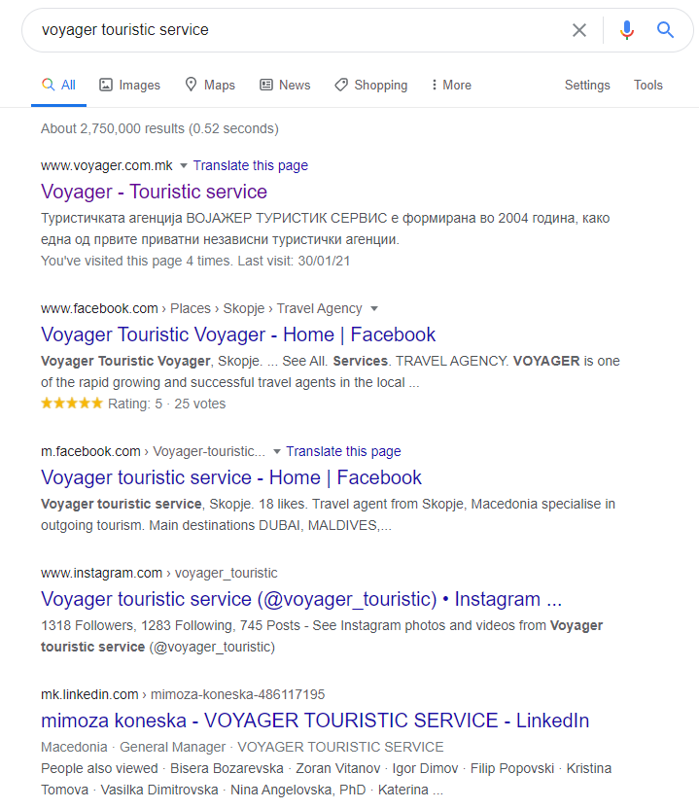
Optimize the Search Engine

Search engines have formulas, or algorithms that help them order the list of results. Search engines might look at how popular your site is, or what other people or sites are saying about you. They might consider words on your web pages or keywords in the code of a page to better understand the topic. They will also consider the searcher’s geographic location. And, with the explosion of mobile usage, search engines now consider the devices people use when they perform a search.
What words would be used if your customers had to find you on the web? What are the trends? Your goal will be to help the search engines to have your business listed in the first results.

Find keywords

Keywords from Google
When you search in Google, you see some words appearing automatically. If you use a sentence, you will also see some suggestions of sentences appearing. It’s a gift from Google giving you the words commonly used by the searchers. So just try to insert some of these words or texts in your website pages.
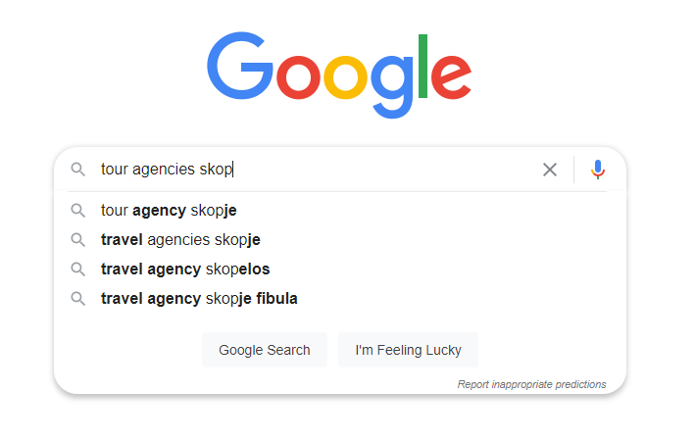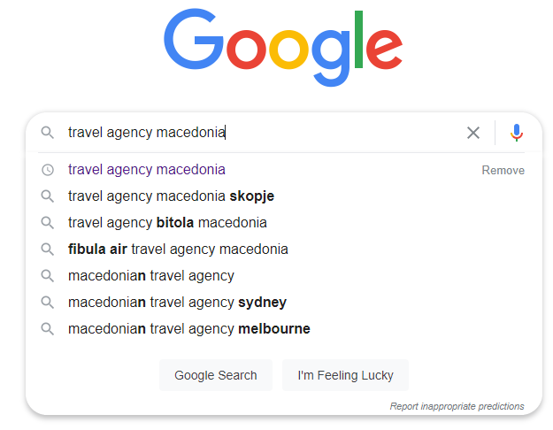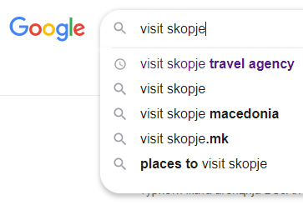
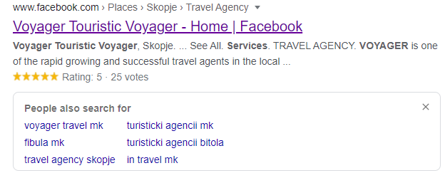

Keywords from your customers
The simplest way to find the keywords is to ask your clients directly. How did they find you?

Keywords with tools
You will find many sites to help you find keywords related to your business. These sites will help you find the words used by Internet users and may inspire you to integrate these words into your site.

Uber suggest
Uber Suggest offer you 3 searches per day for free and It will give an idea on how much would cost a click on some keywords if you decide to advertize using pay-per-click. https://neilpatel.com/ubersuggest/
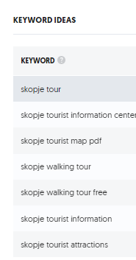
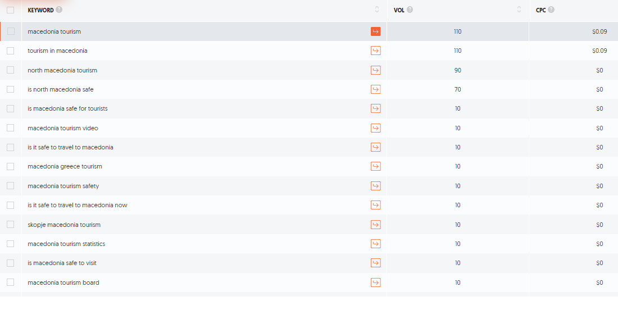
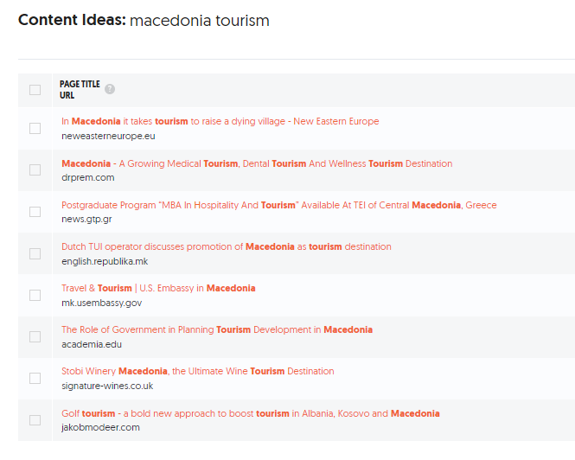
It will give also some content ideas on how to use the keywords in titles or contents of your website.

Answer the public
A very easy way to find keywords is to ask the site www.answerthepublic.com. You can have 2 free search per day to find what phrases or group of words people are looking for when they need a product or service similar to yours. It might be interesting to incorporate these phrases into your website since the search engine has already listed them. This is where the content benefits from being as relevant as possible to your customers.

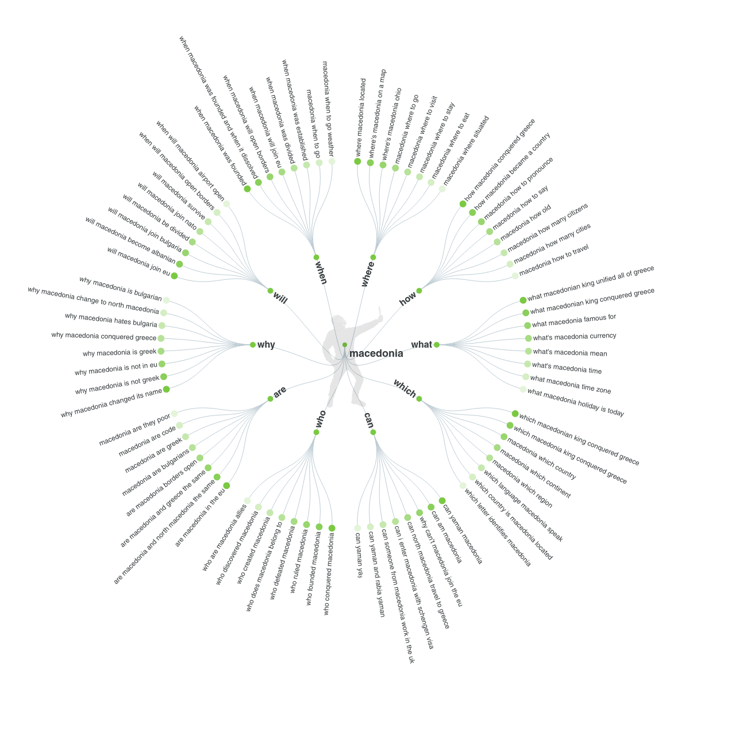

Also asked
Another site where you can find suggestions of keywords: https://alsoasked.com/

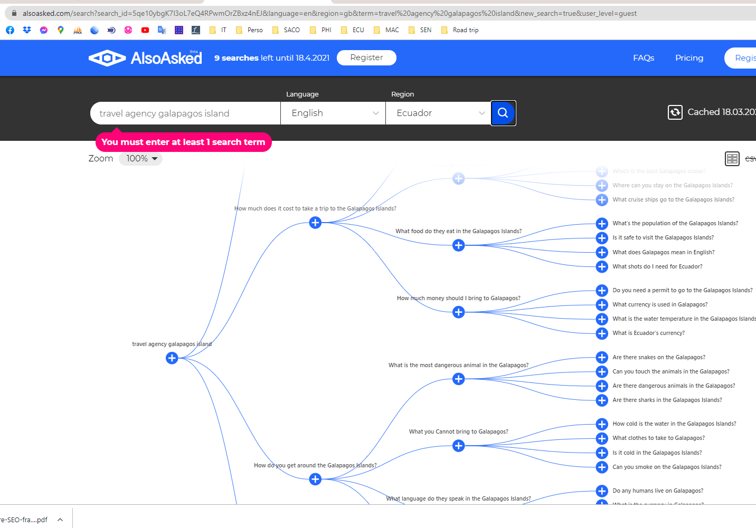

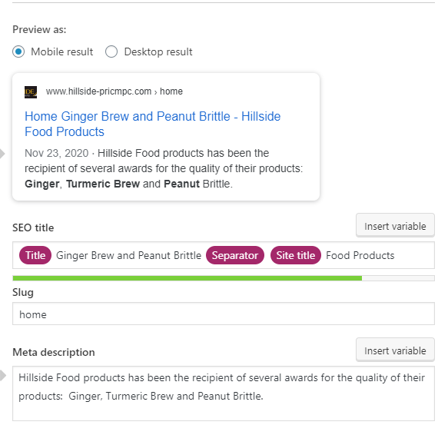
Landing page
Landing page optimization refers to the process of enhancing or improving each element on your landing (Home) page to increase conversions. It’s the main page that users receive when they are searching, so you must optimize this page if you want them to continue in your website. But first, this page should help you to get users inside. Elements you should consider:
- Make your offer clear
- Simplify your landing page
- Use contrasting colours
- Keep the important part above
- Keep your call-to-action buttons straightforward
- Add contact information
- Add testimonials to help convert undecided users
- Complete the options suggested by Google
With the help of Yoast plugin, for optimization, here are the results that will appear after a search with Google.

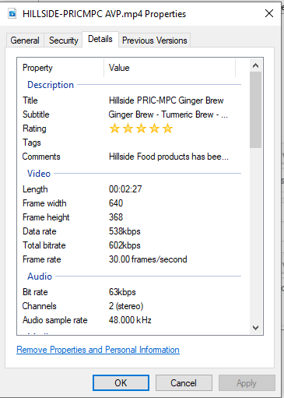
Videos and pictures
MP4 videos are ideal for optimization. Give a full keyword phrase to your video. Name the raw file the same. You will reach the metadata by clicking the left button of your mouse on the video, click properties and then Details.

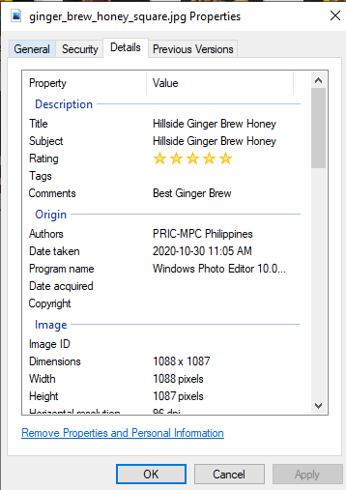
Complete the metadata of the video before uploading.
.

For pictures, all the properties should be filled. It’s the kind of information that Google looks to find you.

Responsive Design – Mobile
Web browsing on-the-go is very much a part of everyday life – which is why a mobile presence is important for businesses to embrace. Your website use a responsive design, which automatically detects the type of screen being used and displays the site accordingly. Your site is mobile-friendly, verified with Google’s Mobile-Friendly Test tool.
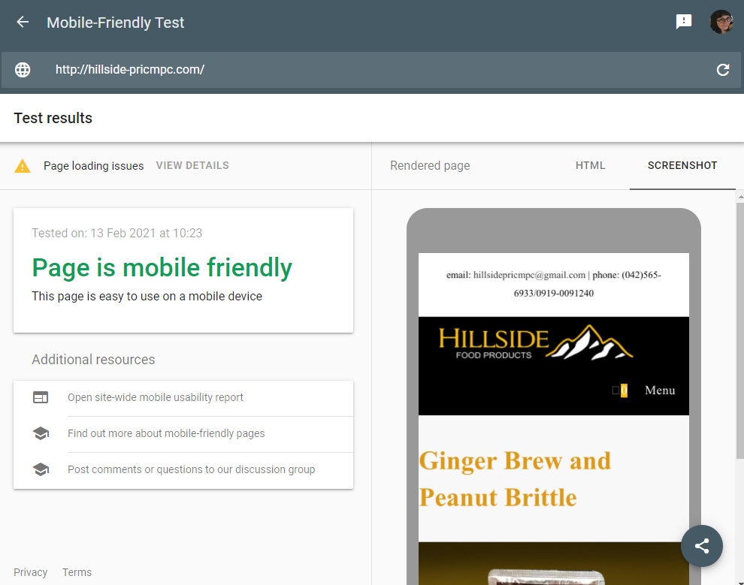

Get Noticed Locally

Google My Business
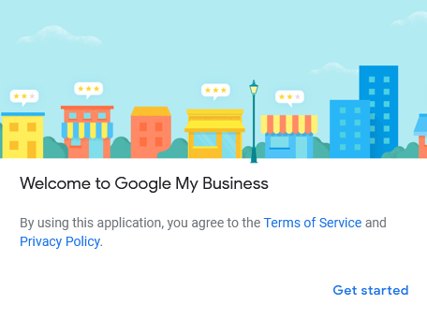
Most Internet and cell phone users use Google when looking for information or a product. It is therefore necessary that your business appears during a Google search. If you want to capture the attention of customers walking around you in your locality, your business must appear in Google Map.
To get there, you need to register your business in Google My Business. This service is free, you just need to register. Google My Business requires you to verify your business address. To do so, you must accept a verification by phone to get a verification code. Here is the link to register:
https://business.google.com/
The objective is to have a good visibility in Google Map with as much information as possible. Google My Business includes a website for free. It’s very few information but why not build one after all. It has been done for COMPANY.
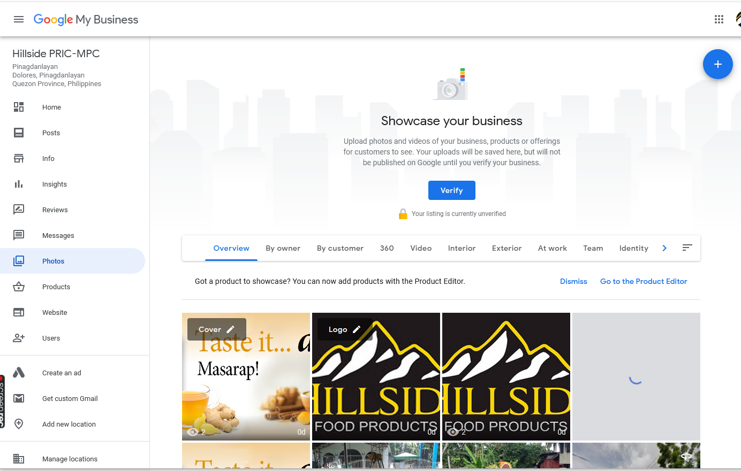
Searching in Google Maps COMPANY, Dolores, Quezon, Philippines will show this result. By completing Google My Business information, you can link to your website. Peoples walking around can see where you are on their cell phone.
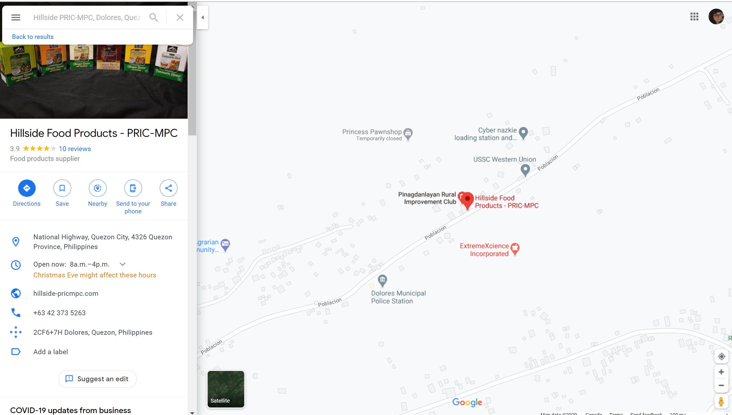

Build on social Media

Everyone’s on social media, so it’s a good strategy for your business to be there too. Which ones your customers use the most? Definitely, for COMPANY Facebook is the main social media. However, I found too many Facebook accounts and pages on COMPANY not updated regularly; it would be better to close them.
Instagram doesn't seem to be an avenue but COMPANY should consider that 10% of the population in the Philippines is on Instagram and mainly are in the young generation. I suggest that the cooperative find in its members, a person who could feed an Instagram page eventually.
YouTube is the second most popular search engine in the world with a staggering 2 billion users. It belongs to Google. COMPANY has now a YouTube channel so that the videos circulate in another social network. Video editing training can be organized later.
In all Social Media, being consistent is important. So I suggest to have the same approach in all Social Media, same colours, and same messages. You should regularly create content and engage with followers. A good practice will be to dedicate one day per semester to create and prepare content for the coming months. You can then post and schedule the contents for dates.


Facebook
The Facebook page is available at https://www.facebook.com/COMPANY
We can go in Facebook from your website in the footer. It’s important to fill all the information required by Facebook and bring the followers into your website where they can buy your products. Some posts (videos) have been scheduled for January and February.

Instagram

YouTube
A YouTube channel has been created for COMPANY and is also available from your website in the footer.
https://www.youtube.com/channel/UCBlhazCNrvrDRT2Ri18BhkQ
5 videos appear in this channel and a link to your website is available.

Advertise on different platforms
Display advertising gives businesses the chance to pay for their ads to appear when the right kind of person is on the right kind of page. If you have a budget for advertising, you might look networks matching businesses with different websites that have ad space to sell. You might also find some partners or organizations that would accept to advertise your business for free on their website.

Paid Advertising
Another way is to advertise with search engines like Google and Bing. How does it work? You give instructions to Google on your goals, where you want to advertise global or local and your monthly budget. We call this model Pay-per-click. Google will display your ads when people search for products or services like yours. You’ll pay for results, like when people click your ad to call your business, visit your website or get directions to your shop.
Remember that the search depends on what the clients are looking for on the web. So you must find the right keywords that will bring the clients on your website. The cost of the keywords can be incredibly cheap or grossly expensive, with the price per click ranging anywhere between 50 cents to 50 dollars per click, depending on the competition level and the industry you're in. Finding the right keywords is a science!

Social media have also paid advertising. For example, if you pay an amount your post will be presented more often by Facebook.
This digital marketing plan aims to use everything that is free on the web to promote your business. But it is interesting to know that several avenues are available to you.

Newsletter
Email marketing is a great addition to your other digital marketing activities because it builds customer loyalty and engagement. A training for automation of the newsletter in your website can be organized later.

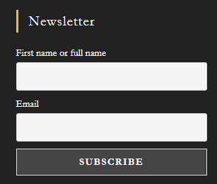
Inscription to the NewsLetter
To use this marketing option, you will first start by building a list of people who’ve expressed an interest in your business. I would suggest doing a contest, or give some discount if the customer signs up for your newsletter. This can be a simple sign at the front desk of your organization where they can fill out a small form by hand.
In your website, I have included a newsletter form to encourage visitors to subscribe online. It’s in the footer.

List of Subscribers
When entering in your website as an admin, you will find the list of the subscribers in the plugin newsletter – Subscribers. You can create your own email group and send a very simple NewsLetter to your clients or used the plugin facilities to create your newsletters.
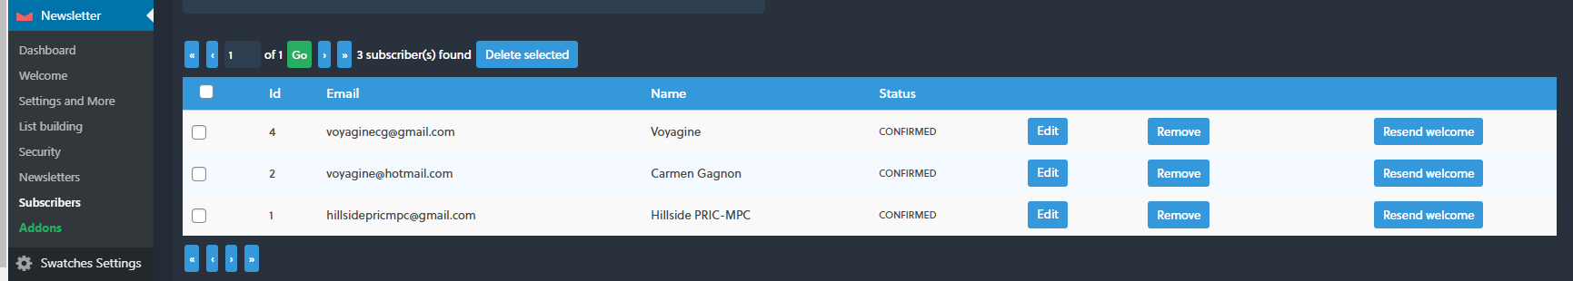

How to build NewsLetter
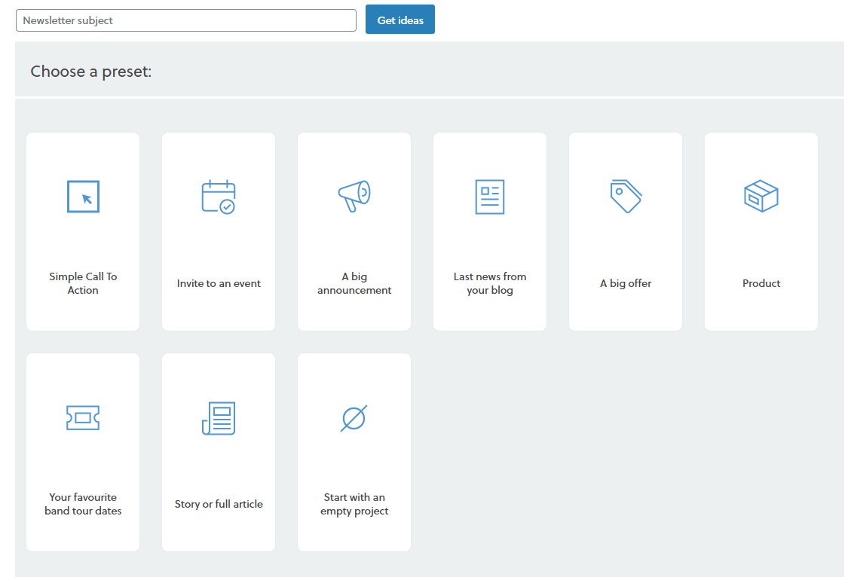
The plugin NewsLetter can be used to create great newsletter but requires more advanced training. We might not have time enough in this assignment. But at least, the clients will be able to subscribe and eventually we can work on this strategy.
Here are the main points to remember:
- Don’t overwhelm customers with too many emails
- Include relevant offers and useful information, be short
- Ask the clients if they are interested in receiving more email
- Find out how they prefer to hear from you: weekly, monthly.
- Be easy to recognize for the clients in the From part of the email
- And very important … provide an easy way for users to opt out of your newsletter.
You will find an example of Newletter for COMPANY in the Newsletter tab. To change the information, pass the mouse over the blocks. You will see an Edit button. You can then change the format using the Blocks option on the right side.
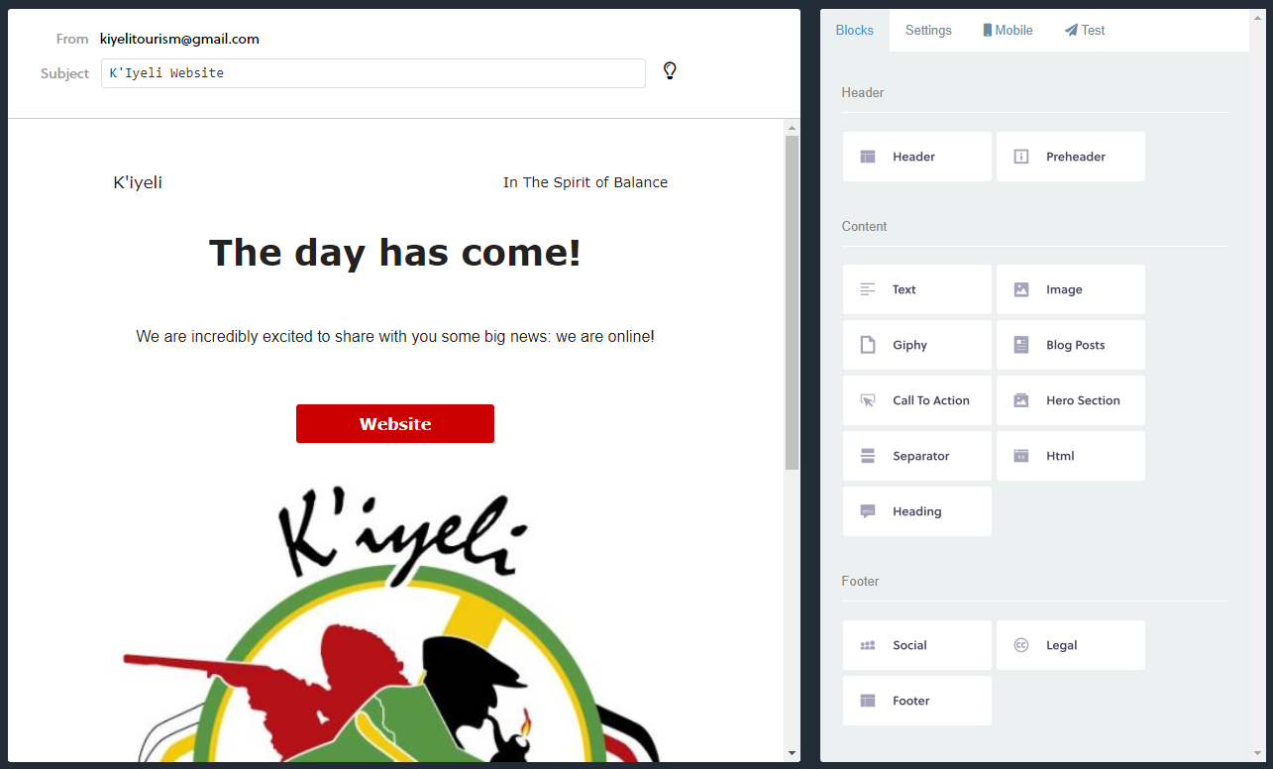
When you are ready, press send Letter. It takes time for the delivery.
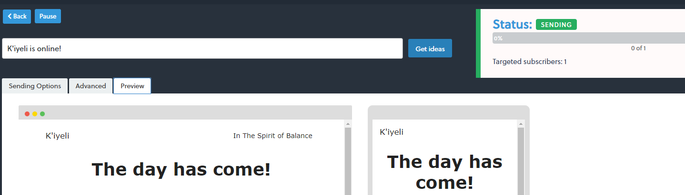Go to NewsLetters to see if it has been sent correctly. You can duplicate the same NewsLetter for creating a new one.
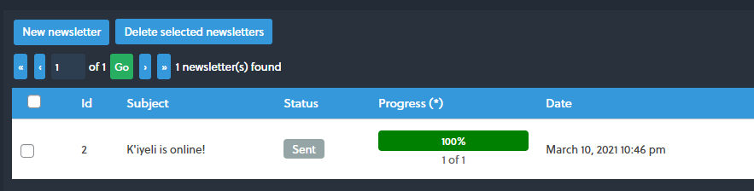

Measure

Google Analytics is one of the most popular digital analytics software that allows you to analyze in-depth detail about the visitors on your website. It provides valuable insights that can help you to shape the success strategy of your business. It may seem complex but you will be able to find interesting information about your customers. This tool will compile data useful for a marketing specialist you may engage later.

Register with Google Analytics
The first step to optimize the Search Engine is to give Google all the information about your website. Your site has been registered with Google Analytic on 2020-12-29. Google started to compile the data from this date. To create the link with the website, we must copy the Global Site Tag given by Analytics into the header of the website. The plugin Insert Header and Footers of WordPress insert the tag in every page of the website. This is how the link is created between Google and your website. You will find in the section Measure, how to explore Google Analytics to find answers.


Send Sitemap to Google Search Console
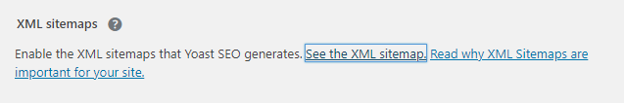
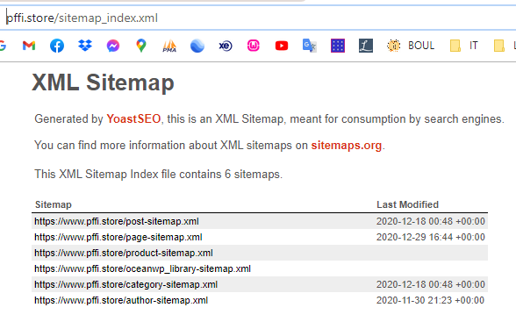
The registration to Google Analytics will also complete your registration with Google Search Console. It’s a free service that gives feedback about how your website is doing in Google search results. To help the search console to find you, the link to your sitemap must be provided. The plugin Yoast, a plugin to help the optimization of the search engine in your website, can create this link for you. In the general settings of Yoast, under Features, you will find this option after getting the verification code Google under Webmaster Tools of Yoast.

Once you have the sitemap link, you will have to copy this link in Google Search Console.
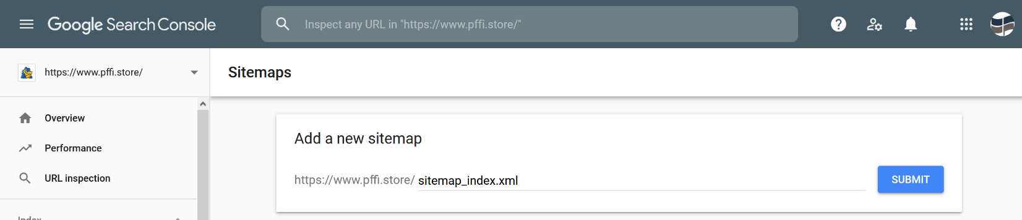
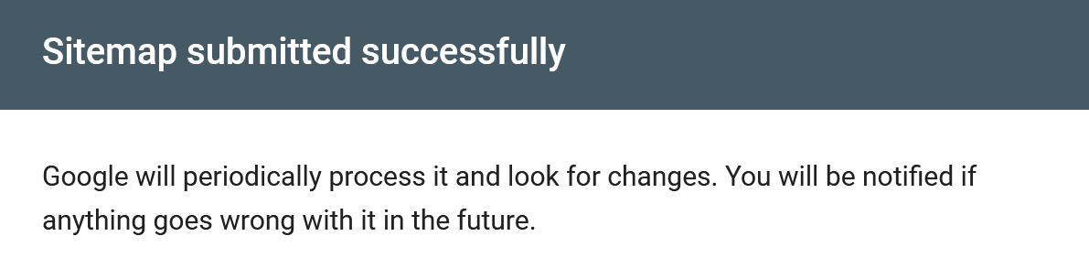

How to Use Google Analytic
To access Google Analytic, you must sign in your Google account with the Gmail indicated in Appendix 1. After go to https://analytics.google.com Your website is already in Google Analytic, so you will just have to browse the tool. Here are the main section you might want to explore. In all sections, you can customize the interval of dates.
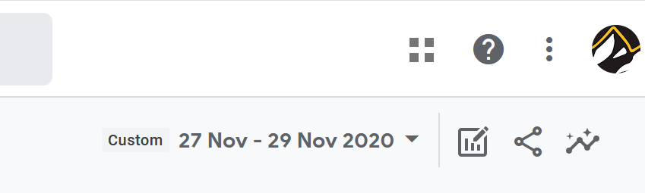

Acquisition – How people find your website
Google tracks how many people land on your website after clicking on a link in search results (organic results), how many people come from links shared on social media, from other websites, from paid ads, and by typing your website directly into the search. You can evaluate if the efforts you make on social media are useful. Click on Acquisition – Overview

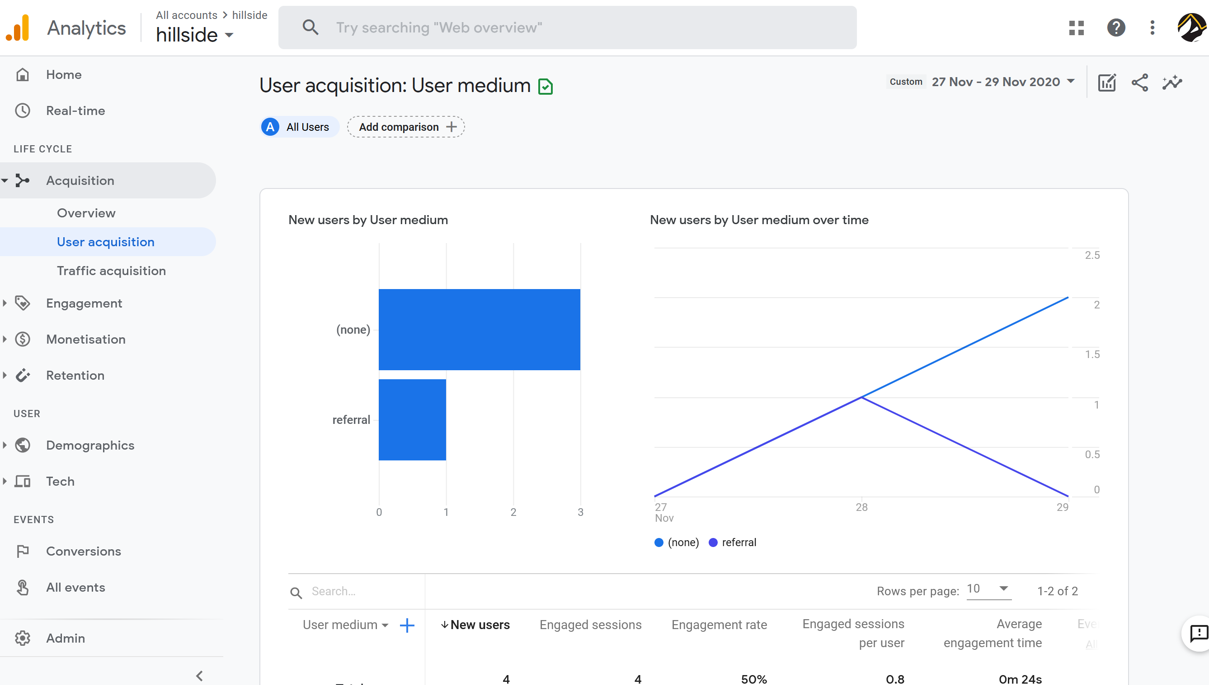

Engagement - What people do when they’re on your website
The Engagement section in Google Analytics provides information on which pages people often come to first on your website, what pages they click through to next (if any), and how long they spend on your website.
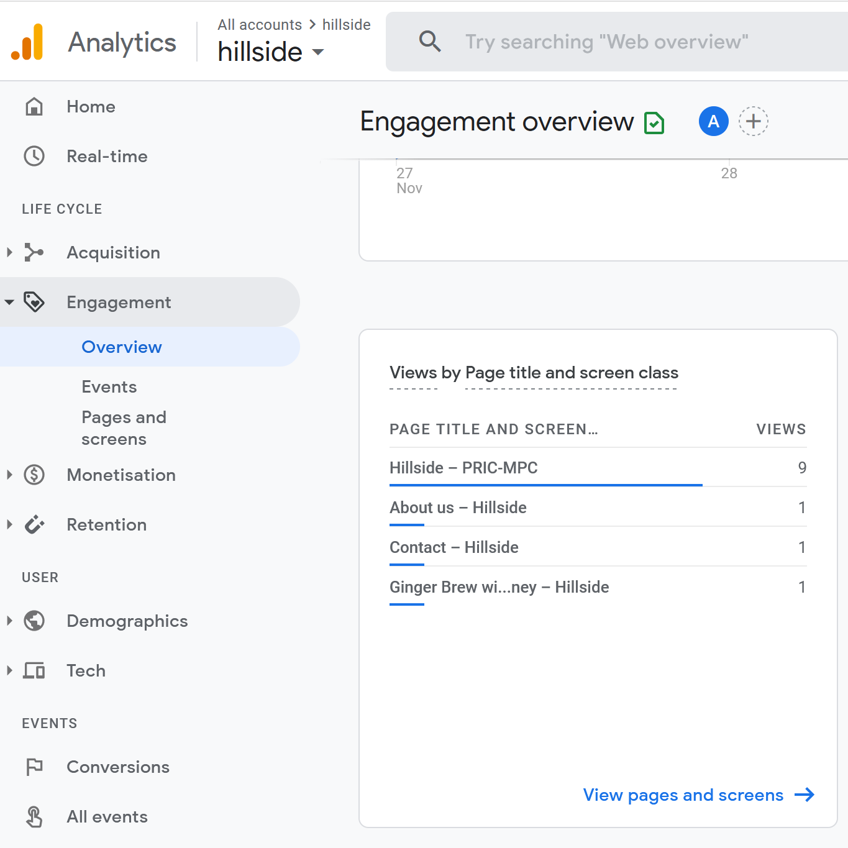

Demographic – Who is visiting your website
Google Analytics provides information on whom the people visiting your website are in terms of demographics, geography, and their general interests online.
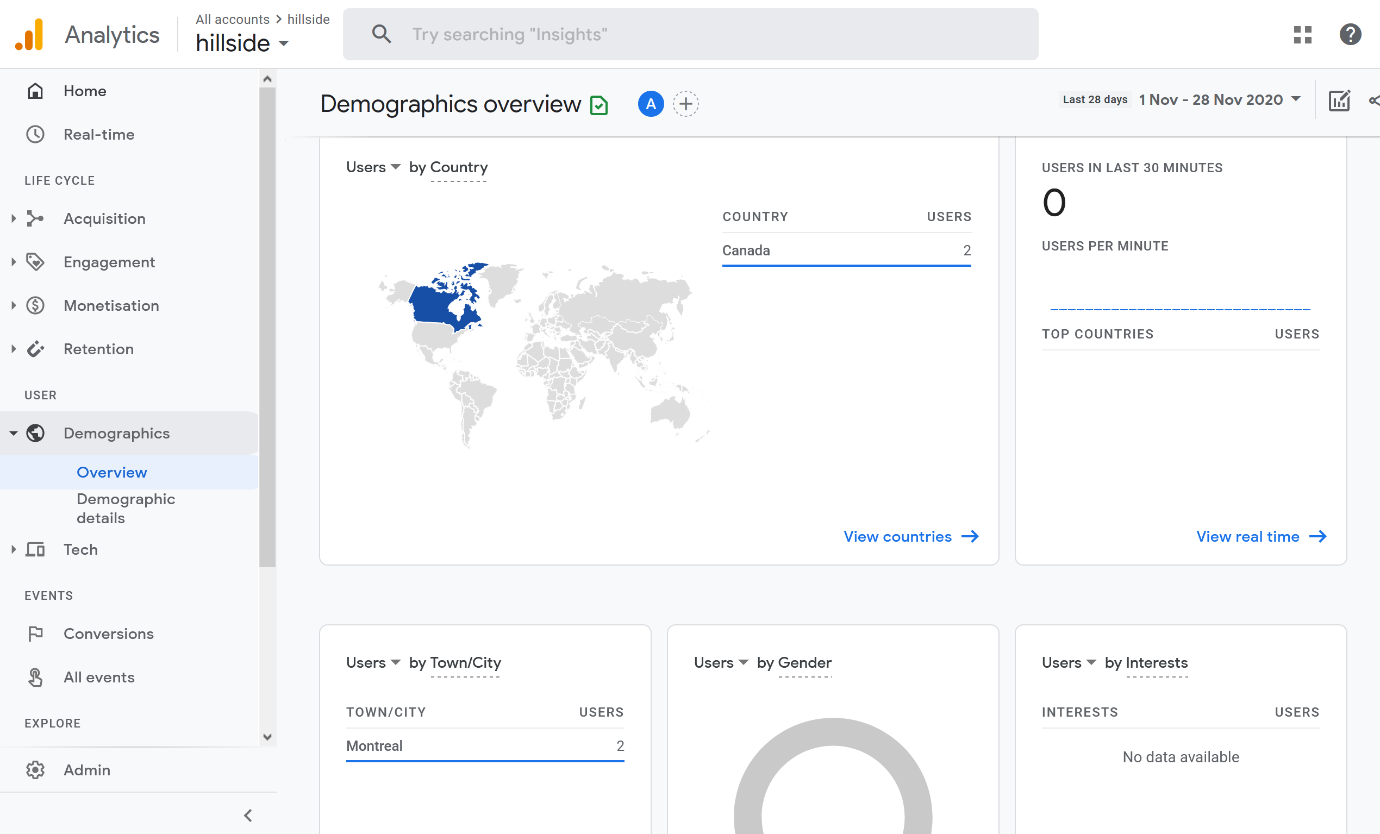

Technology – How they visit your website
What browsers they use and what devices they’re coming from? If your website offers a different experience on one device or browser versus another, you may be losing some visitors. Seeing how many people visit your site on mobile or through Safari lets you know how important it is to optimize for those people too.
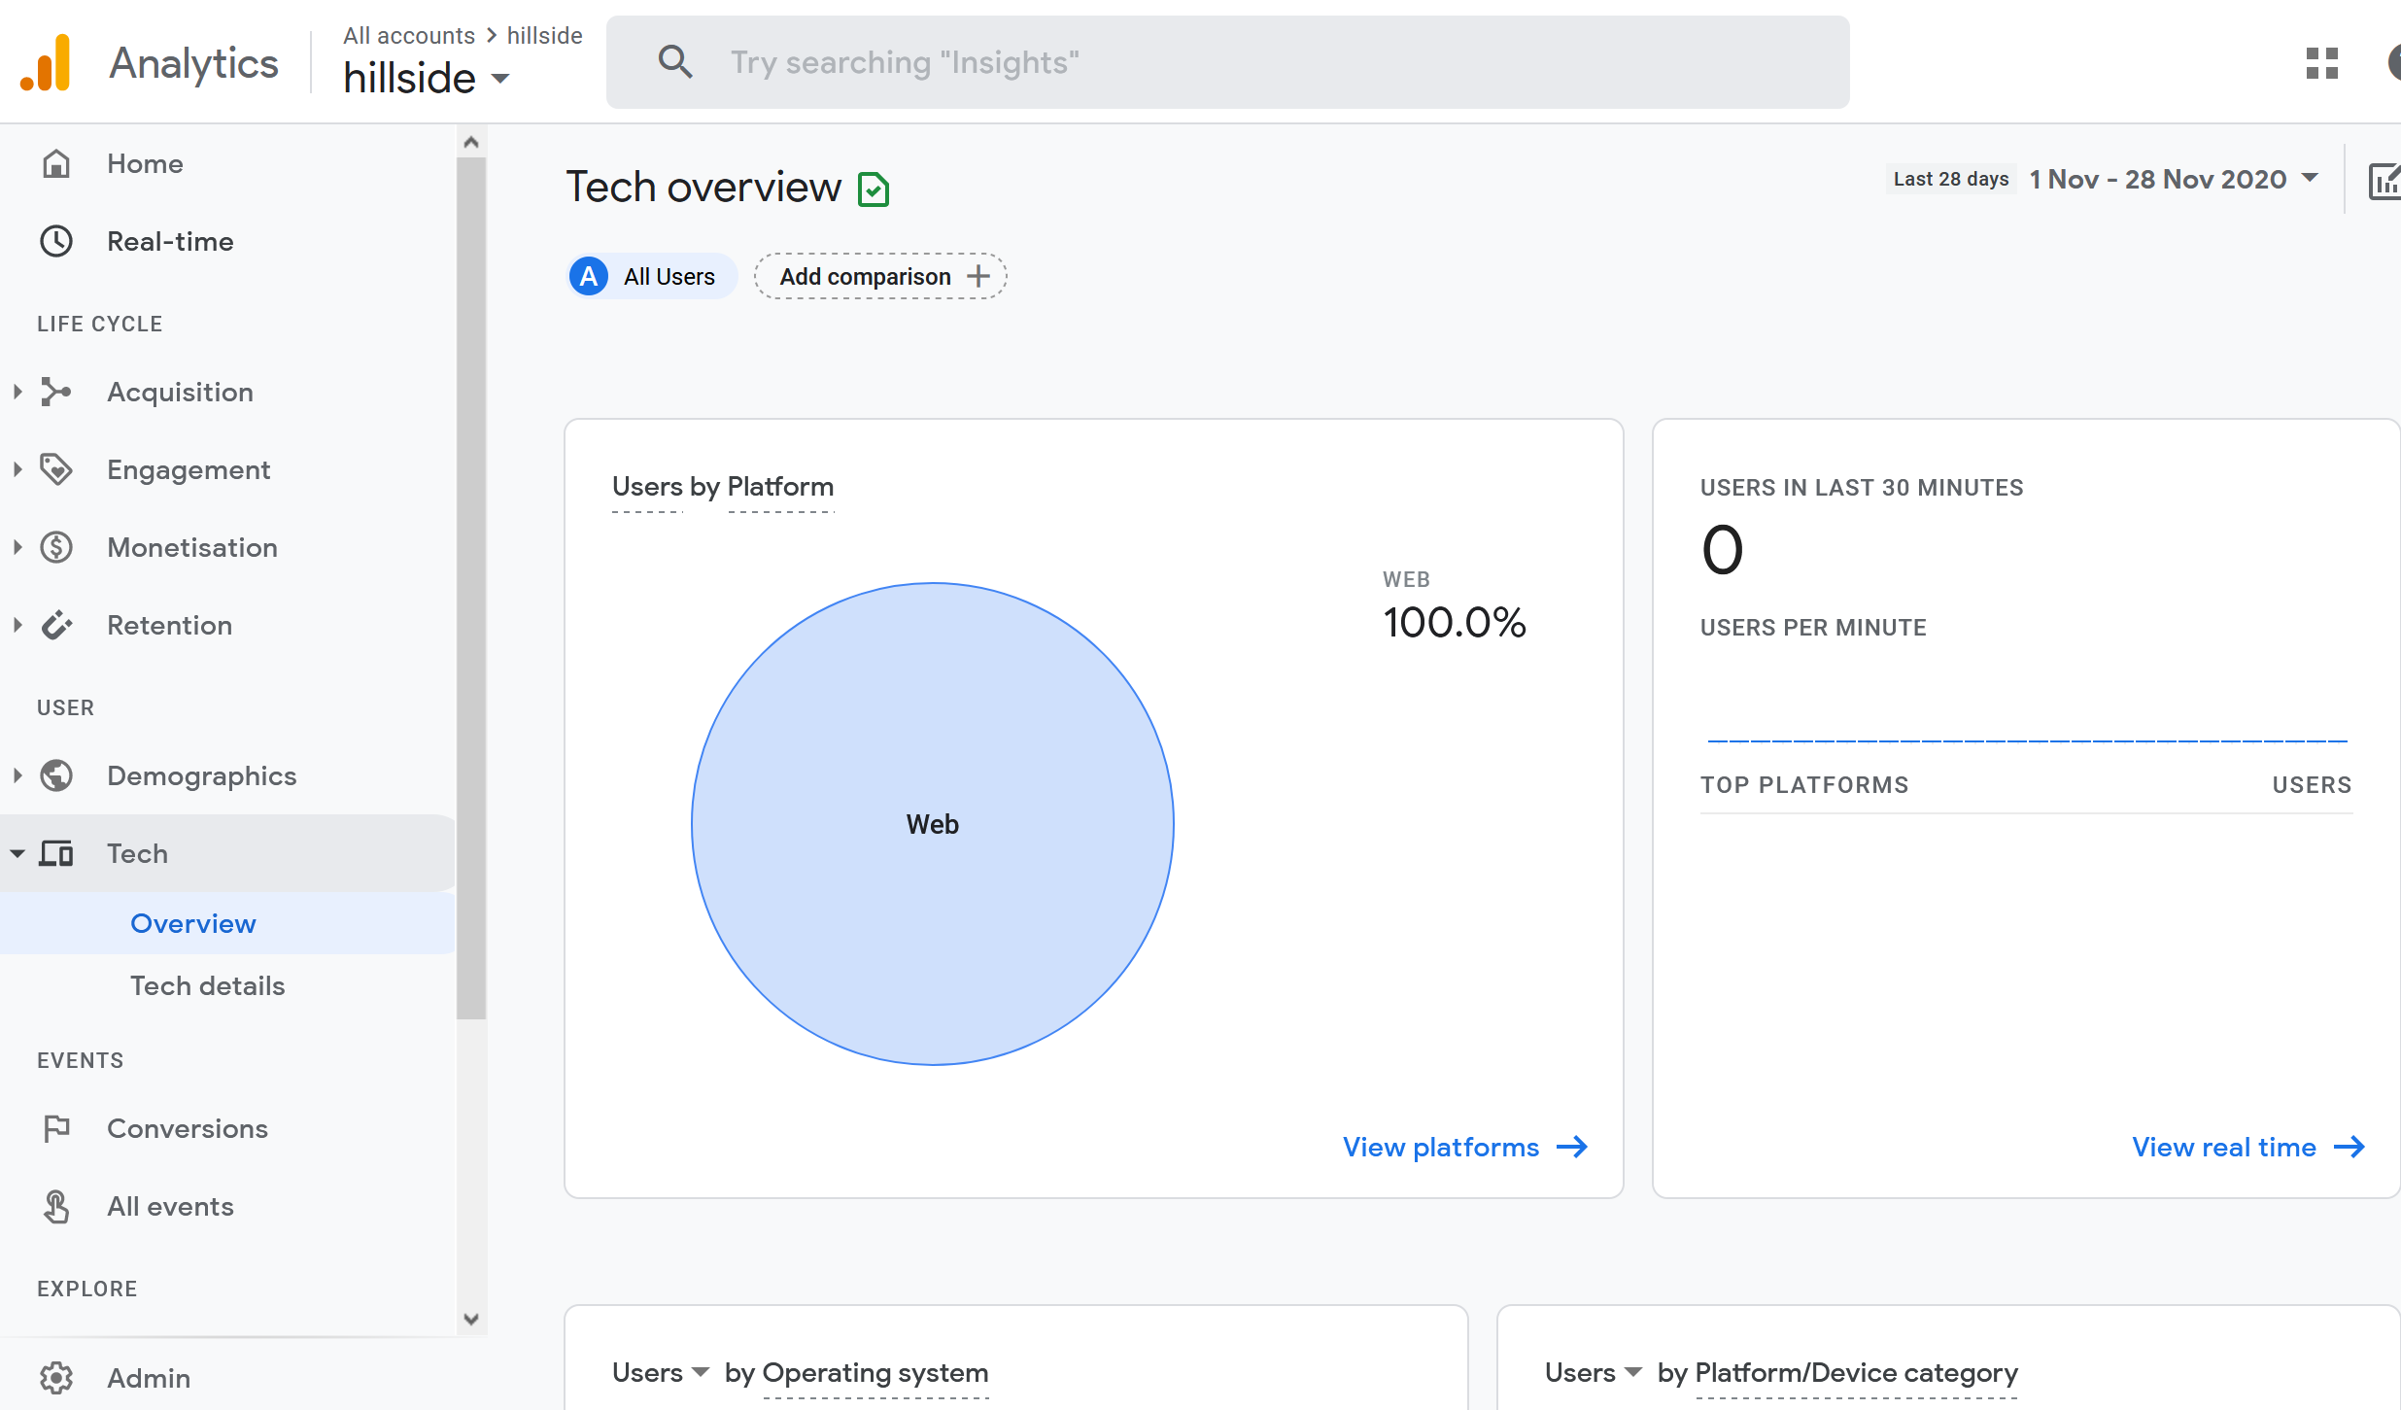

Analytics in YouTube
You can also evaluate your YouTube channel. This will allow you to assess the relevance of a video.

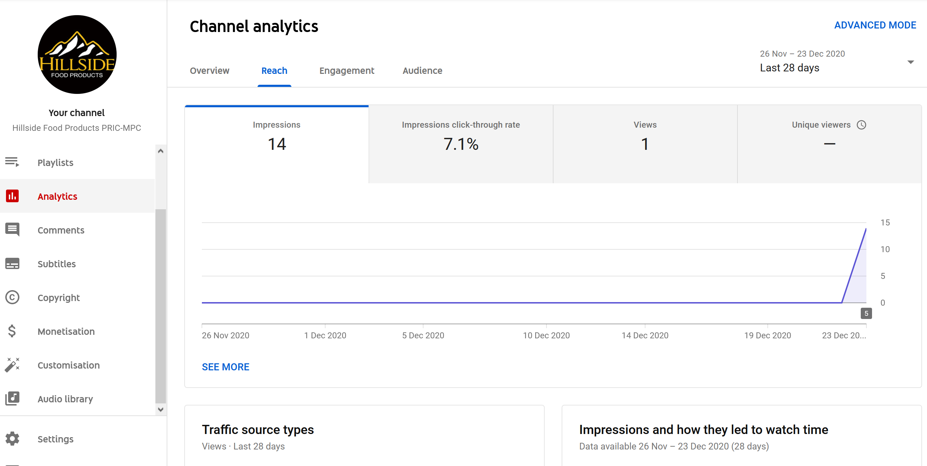

Analytics Facebook Page
Facebook also has an analytics section. For this, you will go in your Facebook page settings and press insights.
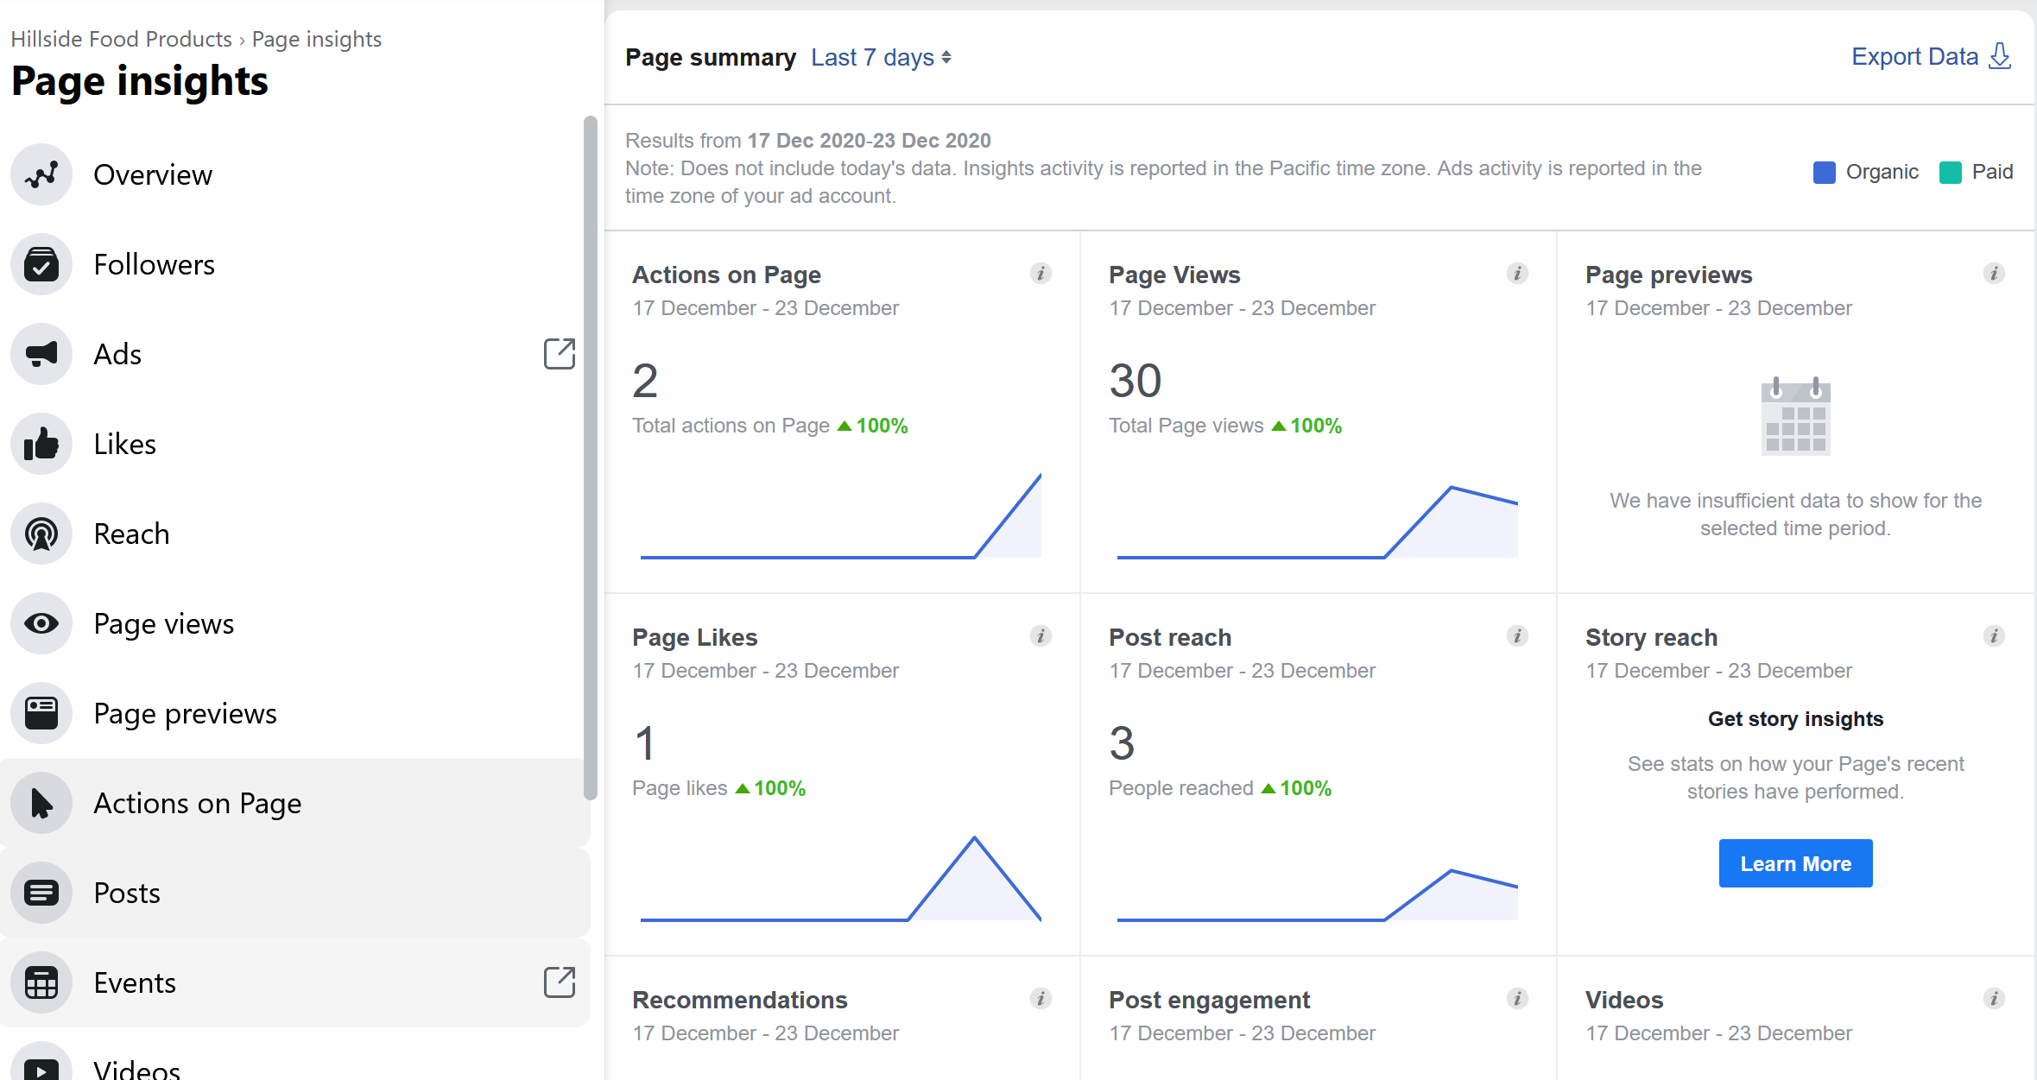
All these tools for measuring your actions on the web can be useful. They can help you to measure how much traffic you’re getting, where you might be able to make improvements and the impact of changes you’re making to your website.

Maintain

Administration of the SHOP

Online shopping for the client
The client can place an order without going through the creation of an account in your website but if he does, he will be able to follow the progress of the order in his account.
For the payment, the client can choose between sending a check by mail or cash on delivery.
Shipping is yet to be defined so the options are Free or Local Pickup.
If the client buys 10+ of a product, he gets 4.5% discount on the price.
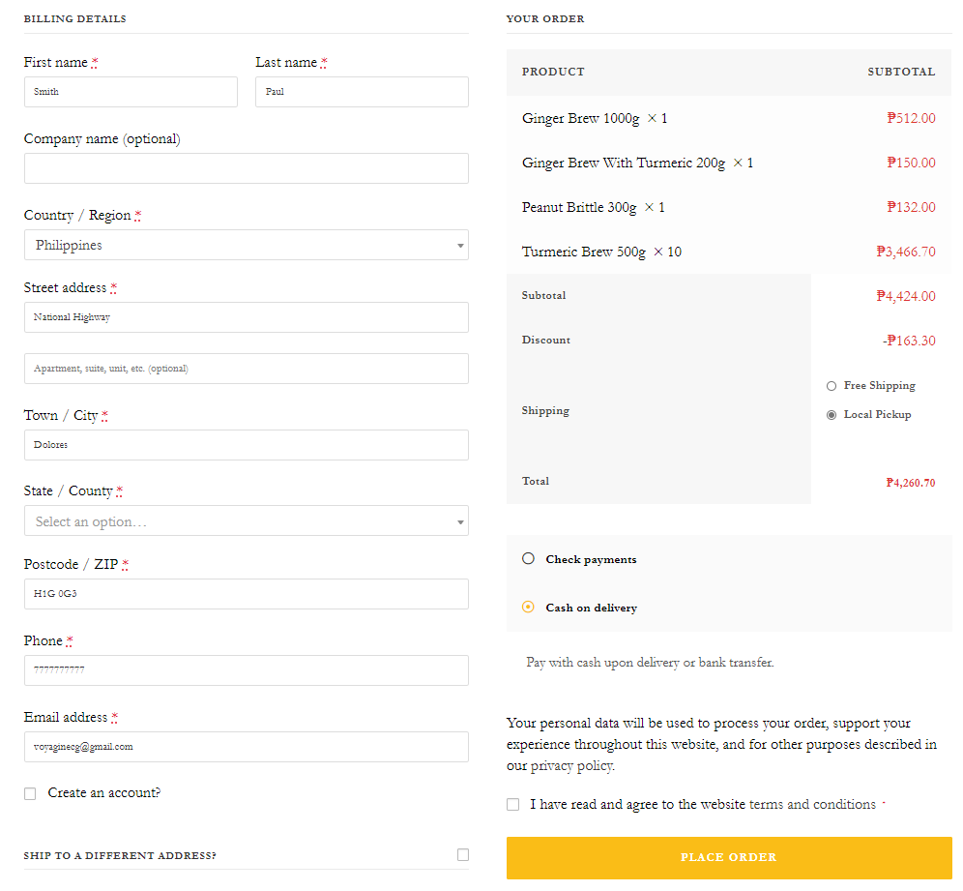
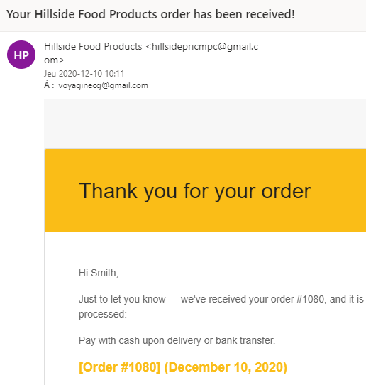
When the client places the order, he gets the message and the order number.
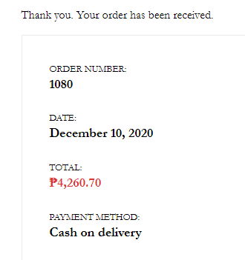
At the same time, the client receives a mail with the details.

Following the orders
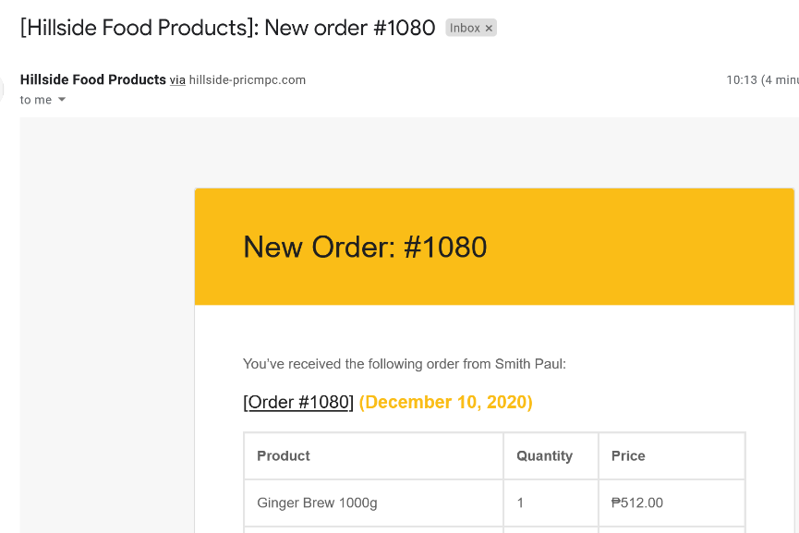
When a client places an order on your website, you receive the order via the mail COMPANY@gmail.com with all the details of the clients.
When a shop starts taking orders, the Order’s management page begins to fill up in your website. Enter your website using the admin code COMPANY and click WooCommerce - Orders
Each row displays several details. Some are there by default, others can be added. These are the options:
- Order number and customer name,
- Date of purchase,
- Order status,
- Billing address,
- Shipping address,
- Purchase total and
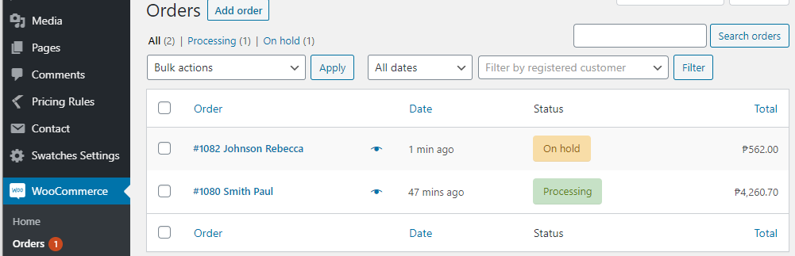
- actions.

Order Statuses
An order also has a status. Order statuses let you know how far along the order is, starting with “Pending payment” and ending with “Completed.” The following order statuses are used:
- Pending payment — Order received, no payment initiated. Awaiting payment (unpaid).
- Failed — Payment failed or was declined (unpaid) or requires authentication (SCA). Note that this status may not show immediately and instead show as pending until verified (e.g., PayPal).
- Processing — Payment received (paid) and stock has been reduced; order is awaiting fulfillment..
- Completed — Order fulfilled and complete – requires no further action.
- On hold — Awaiting payment – stock is reduced, but you need to confirm payment.
- Cancelled — Cancelled by an admin or the customer – stock is increased, no further action required.
- Refunded — Refunded by an admin – no further action required.
- Authentication required — Awaiting action by the customer to authenticate the transaction and/or complete SCA requirements.
The status will depend on the choice of payment of your client. In the above example, Paul Smith is paying Cash on Delivery (Processing). Rebecca Johnson will send a check (On hold) and the order will be in processing status when you will receive the check. You will need to change the status of the order manually. This is how you will administer your online commerce.

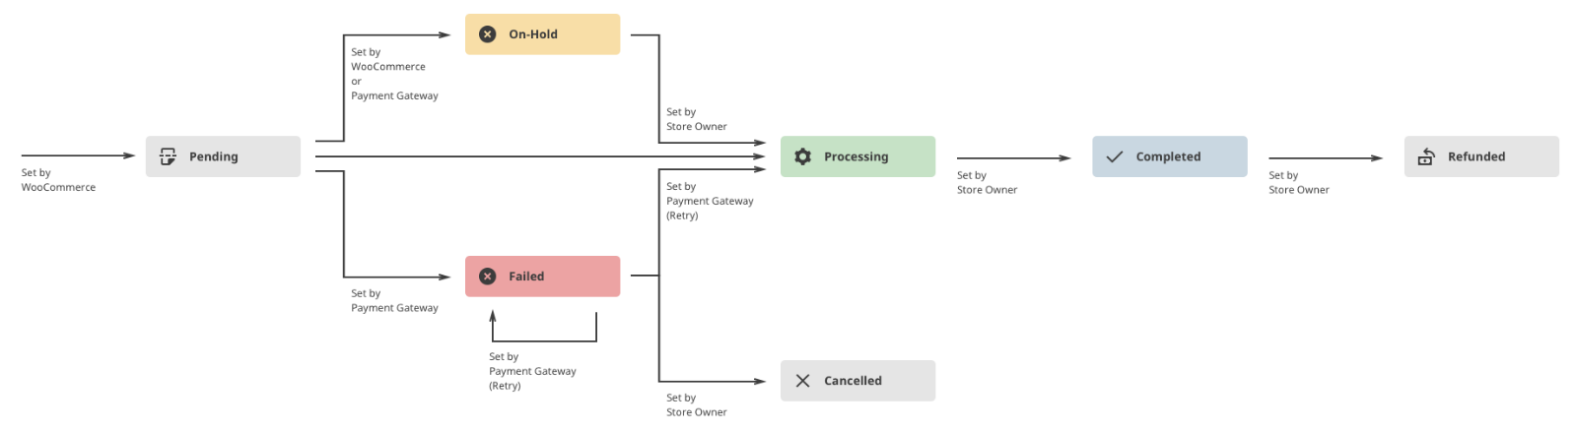

Order Completed
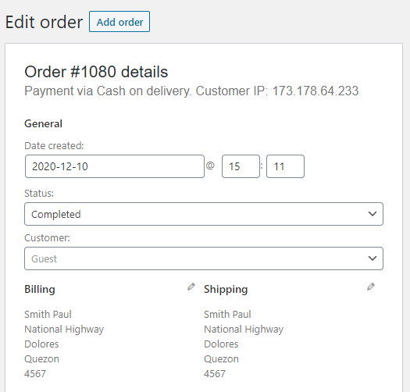
When the order is completed, you will change the status for completed in your online store. The client will receive a mail to confirm that the order is completed.

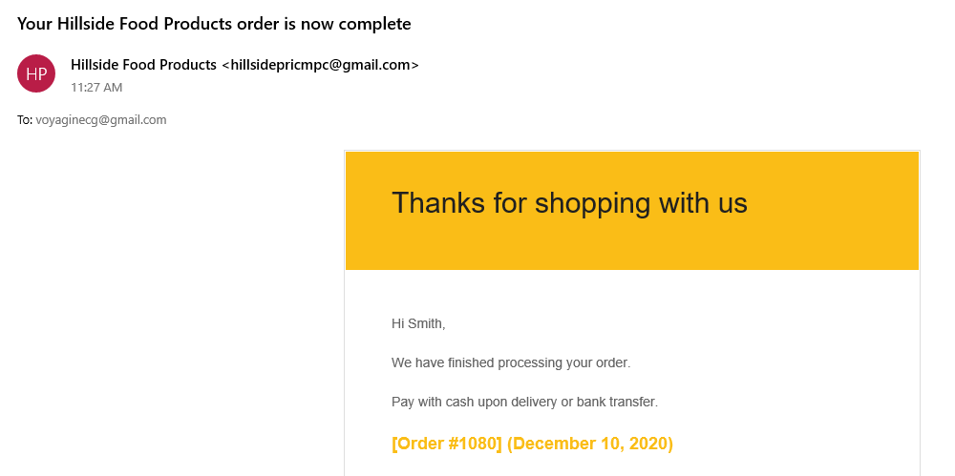

Reports and customers
You will also have access to reports, list of the customers, etc. all in the WooCommerce section of your website. If no username appears, it means that the client didn’t create the account in your system.
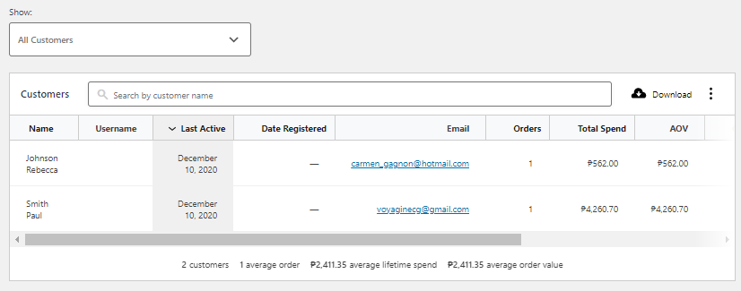
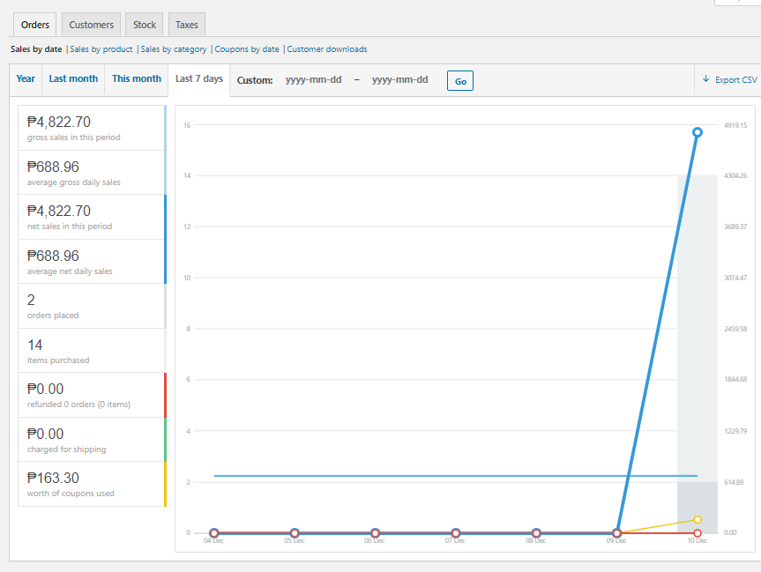

Editing the products
All the products have been created in your website. But you will need in the future to create new products and to update the prices or the details. Enter your website using the admin code and click Products
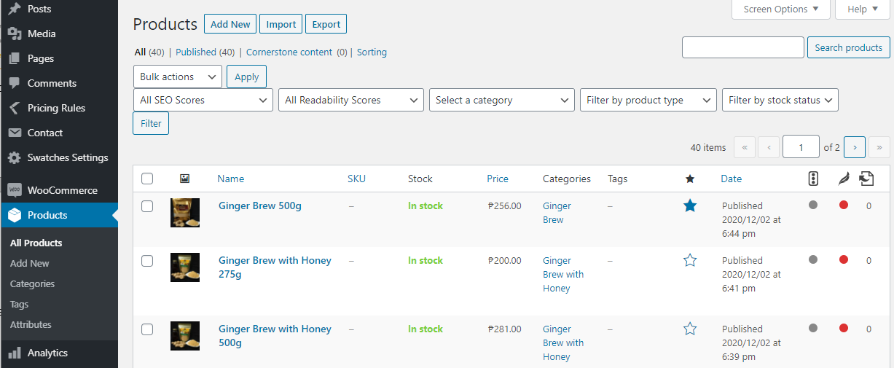
Click Add New to create a new product or click on the product name to update. Follow the steps in the next page.
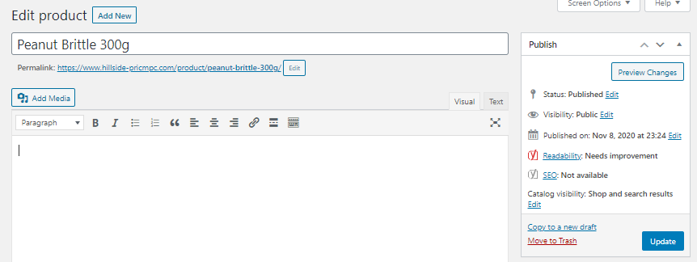
Last steps: Publish if new products or update if in editing mode.
Name of the product
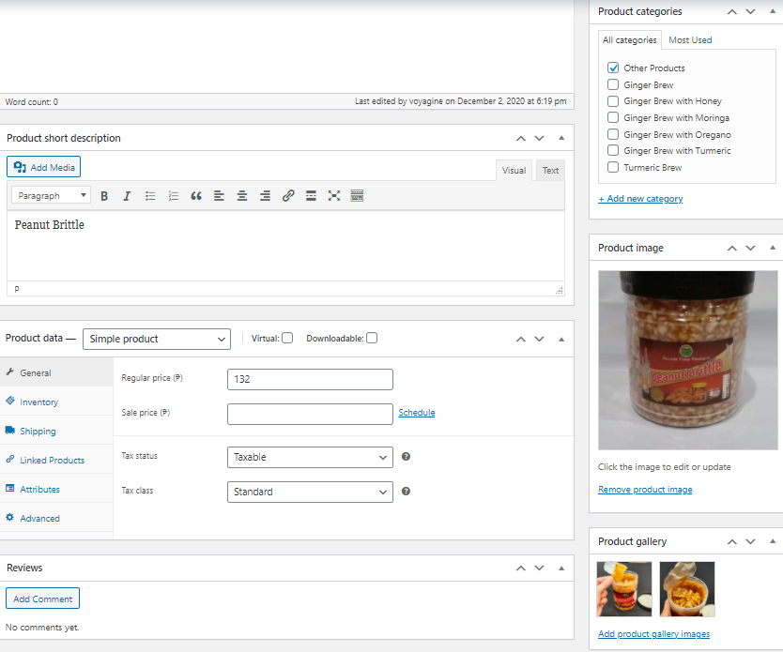
Give more details in the Short Description.
Indicate the category if not it will be in the category Other Products.
Price of the product
If you have more than one image create a gallery.
Image of the product

Shipping Settings
Your store offers Free Shipping or Local Pickup because you didn’t take any decision on this subject.
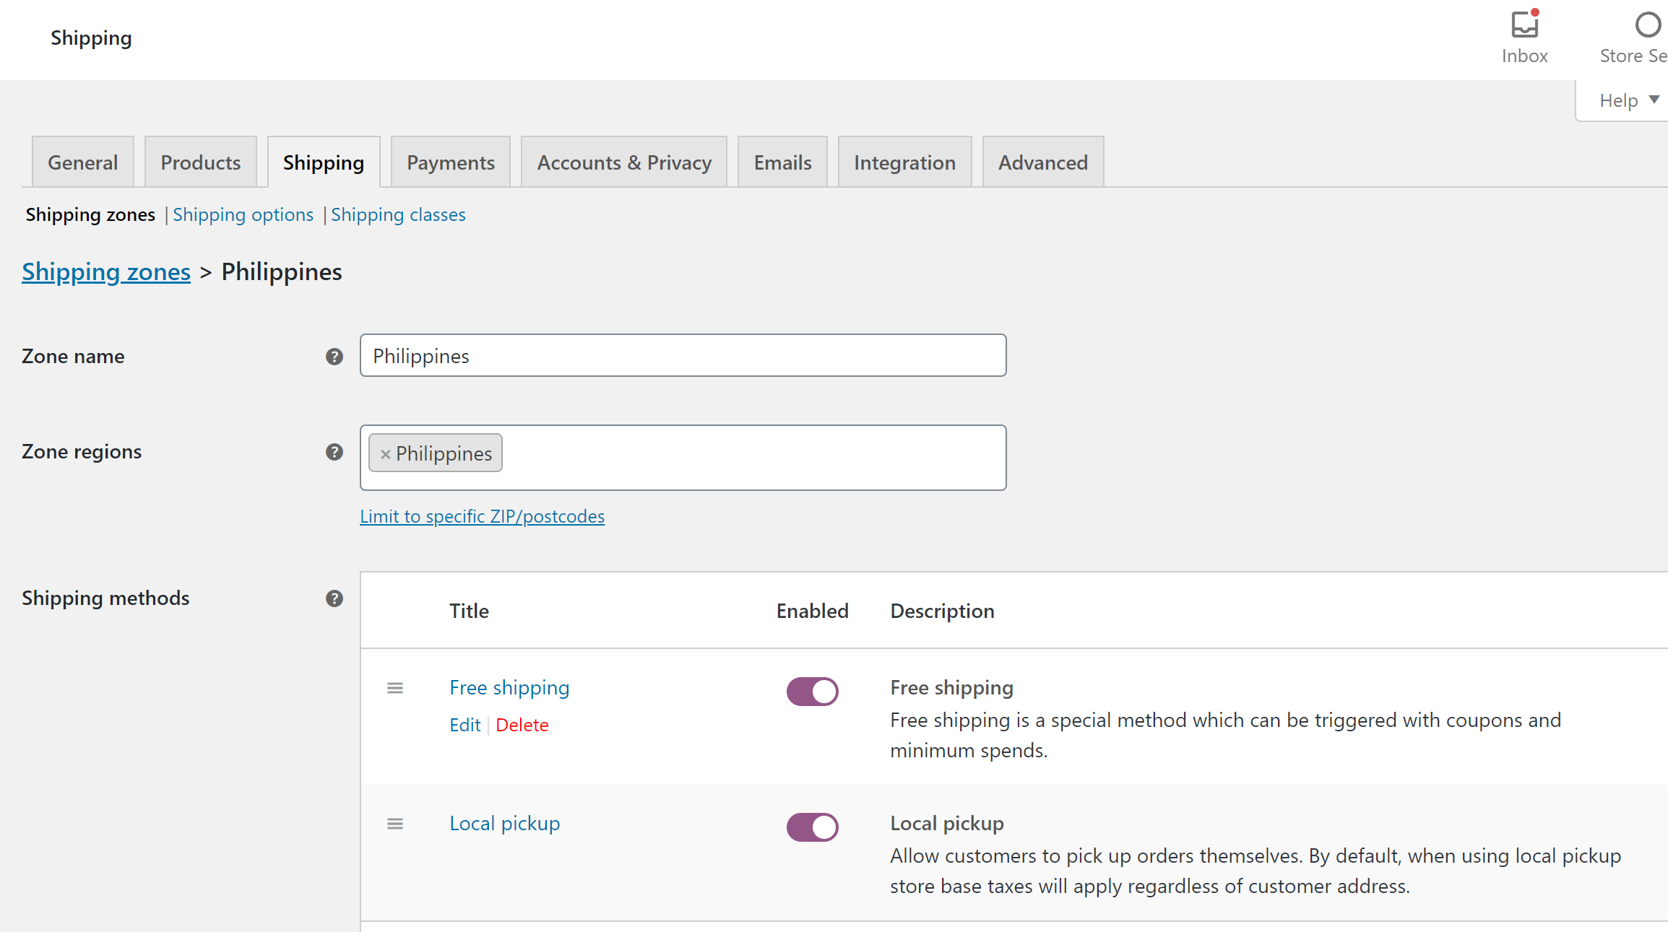
When you will be ready you might have to change the settings and work with the customer zone. You can read about setting up shipping zones at: Setting up Shipping Zones
Go to: WooCommerce > Settings > Shipping.
Shipping Options
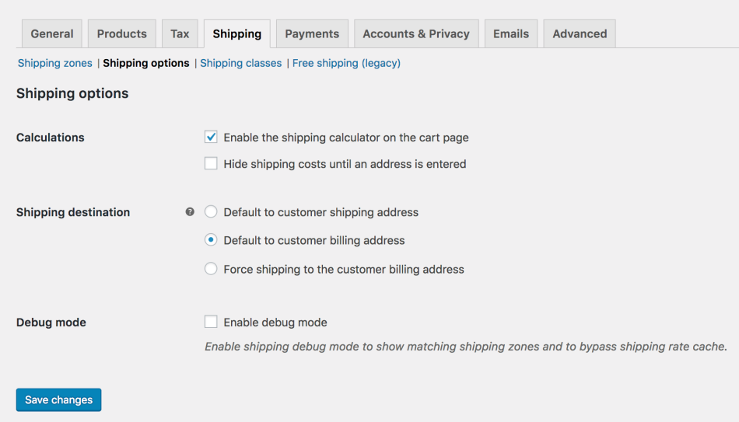

Payments Settings
Your store accept Check Payments and Cash on Delivery.
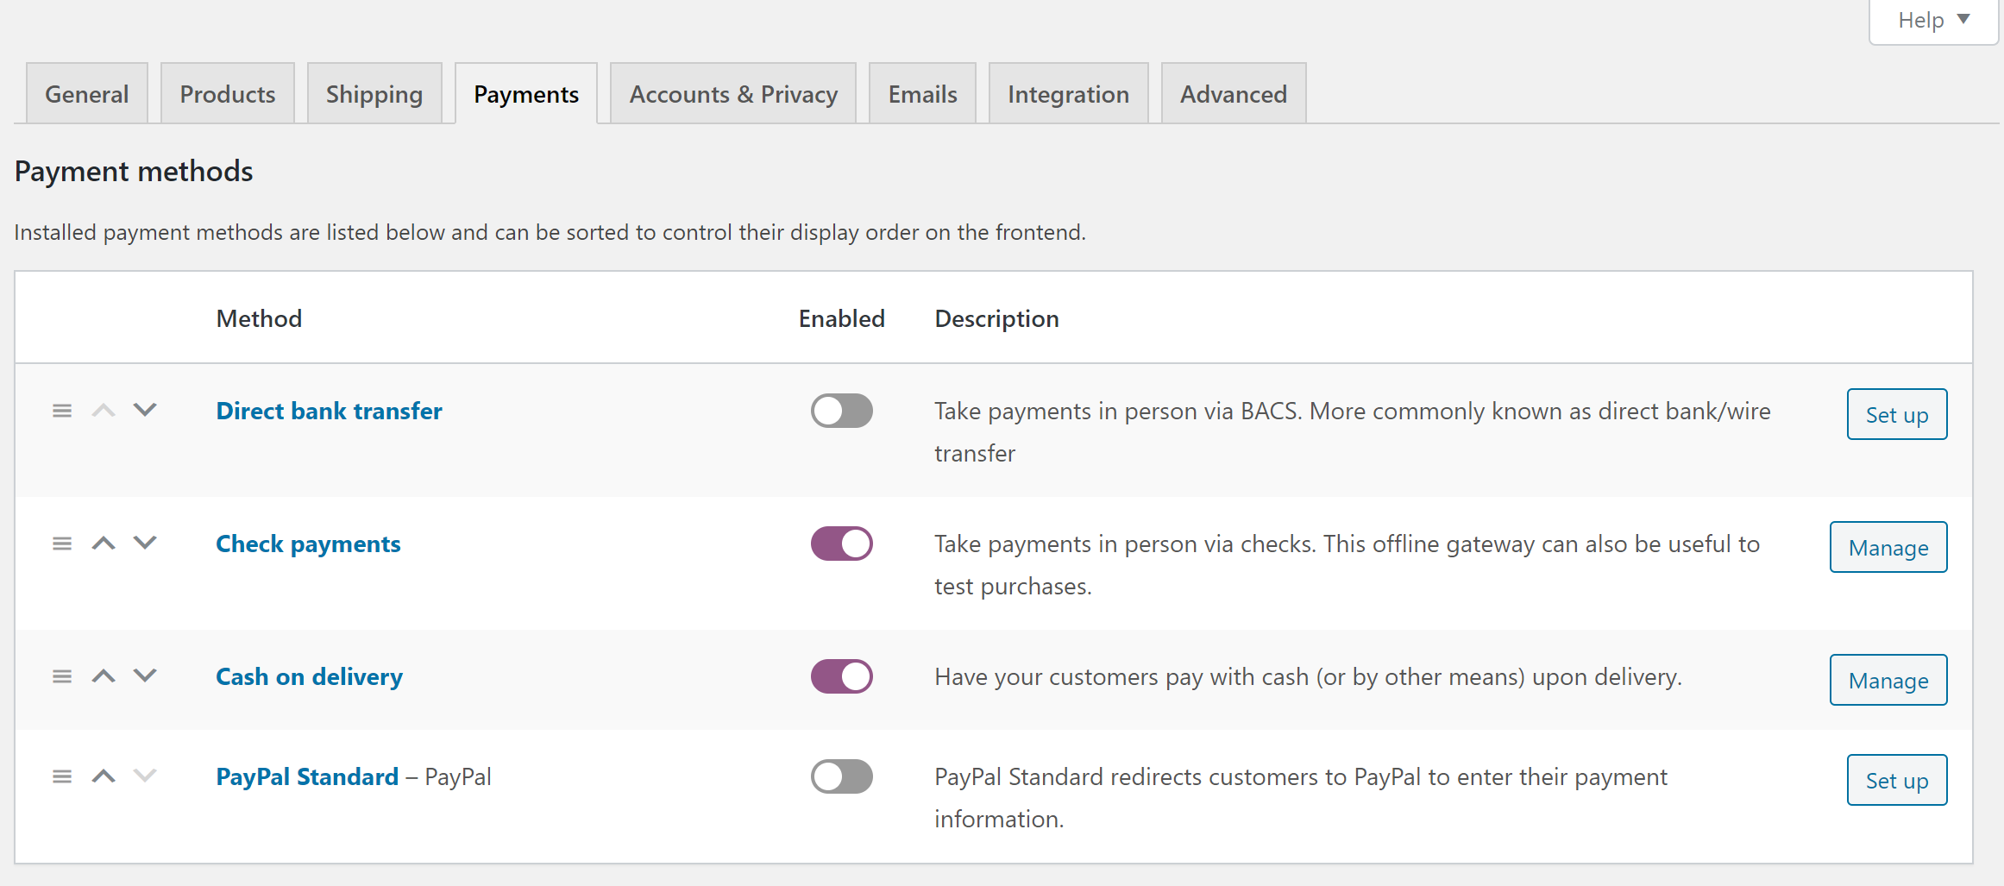
Go to: WooCommerce > Settings > Payments to control which payment gateways are enabled.
Installed gateways are listed and can be dragged and dropped to control the order in which they display to customers on the checkout. Clicking the name of the payment gateway will take you directly to a screen to set up or adjust your settings.
If you try to enable a payment method that needs extra configuration, it will redirect you to the payment methods setup screen.
More information about: Free Payment Gateways included in WooCommerce.

Promoting your content
Once you know which channels to promote your content through, it’s time to create a content calendar. A content calendar is a detailed timeline that organises your content marketing activity. By clearly outlining what to publish and when, it can help make your content process consistent and efficient, as well as give everyone involved a clear action plan to follow.

Content calendar
Here are some tips to get you started on your own content calendar:
- Make it achievable. Your content calendar should include realistic time frames - if it’s not achievable, you’ll fall behind schedule and your content won’t reach its full potential
- Highlight key dates. Things like public holidays or relevant events are great for releasing seasonal content
- Consider multiple channels. Think about how a variety of marketing channels, such as a blog and social media, can work together to promote your content marketing campaigns
- Remember the audience. Clearly define your audience at each stage of the calendar. If you segment your audience, specify which group you’re targeting
- Explore online tools. There’s a variety of free and paid tools available to help you create a calendar, publish content to social media accounts, or collaborate on content with your team. These tools can save you time by automating some of the content creation and distribution process.

Keep your website Blog alive
To keep your site more updated, it will be interesting to continue the blog with the new activities carried out by your organization. Go to Posts – Add New
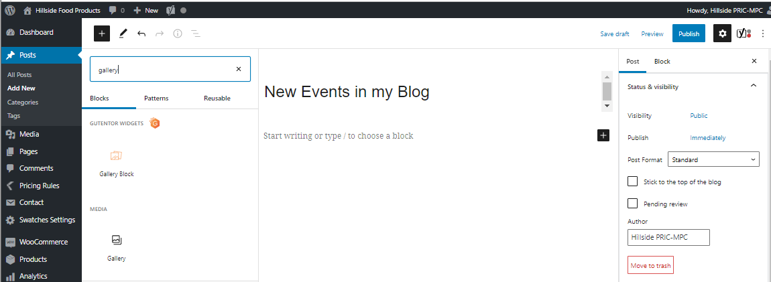
Set a category for the post
Last step
Publish or update
For writing a text
To insert a gallery of images press the + and choose gallery.
Title of the post
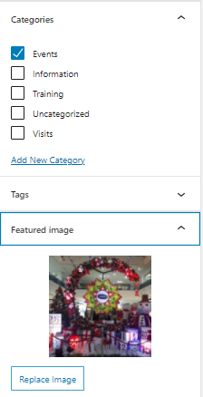
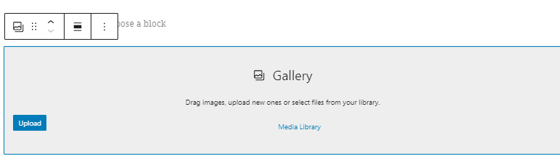
Insert the image that illustrates the whole post.
Upload the image of chose from the library.
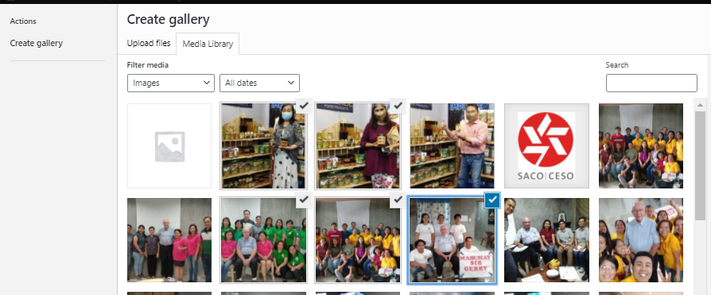

Create Gallery – check the images you want to insert in the Gallery and Insert the Gallery.

Posting in Social Media

Facebook
You will find all the codes and password about your Facebook page in the appendix.
https://www.facebook.com/COMPANY
Don’t forget being consistent and regular on your posts.

Scheduled posts
To schedule post in your Facebook page, click on Publishing Tools on the left side of your Facebook page. In the Published Posts section, you will have some statistics about your posts.
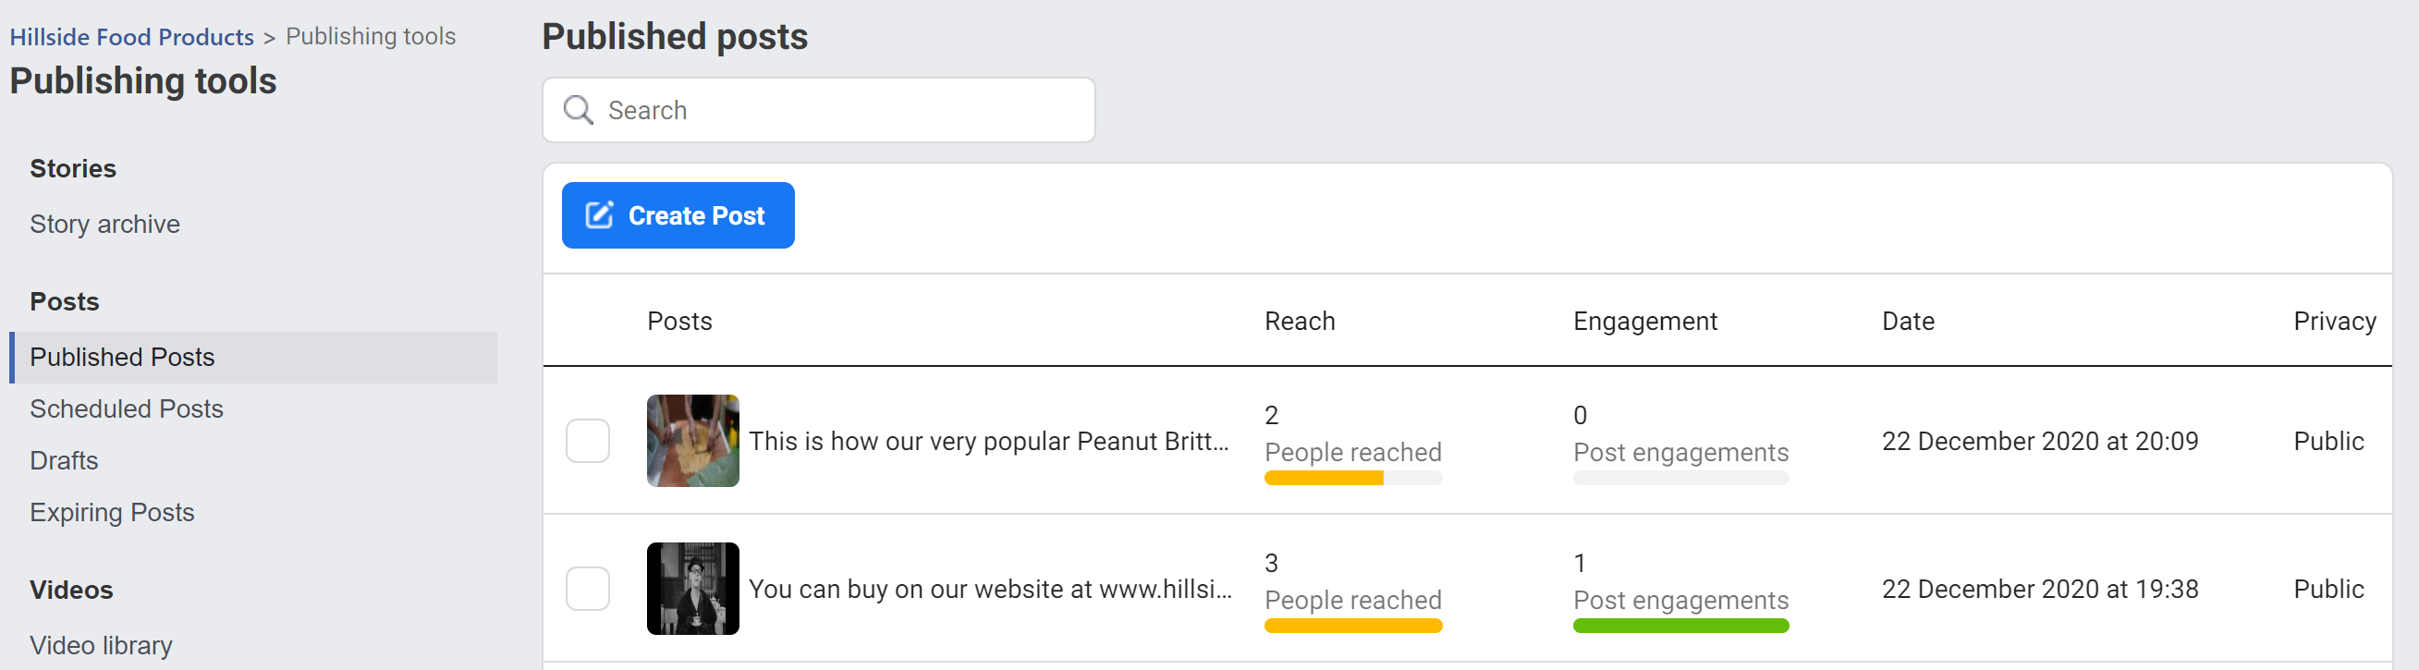
For scheduled posts, click on New Post and fill the information required. You will find the scheduler at the right of the Publish button. This is where you will be able to indicate a date in the future.
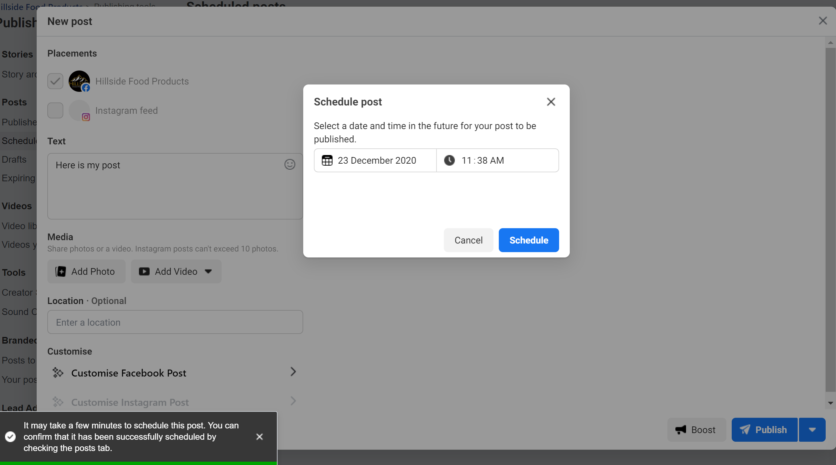
As you can see in the message, it takes a few minutes to have the post scheduled.

Delete a post
To delete or reschedule a post, click in the post and go to action. You will be able to delete, publish, reschedule or cancel the post.

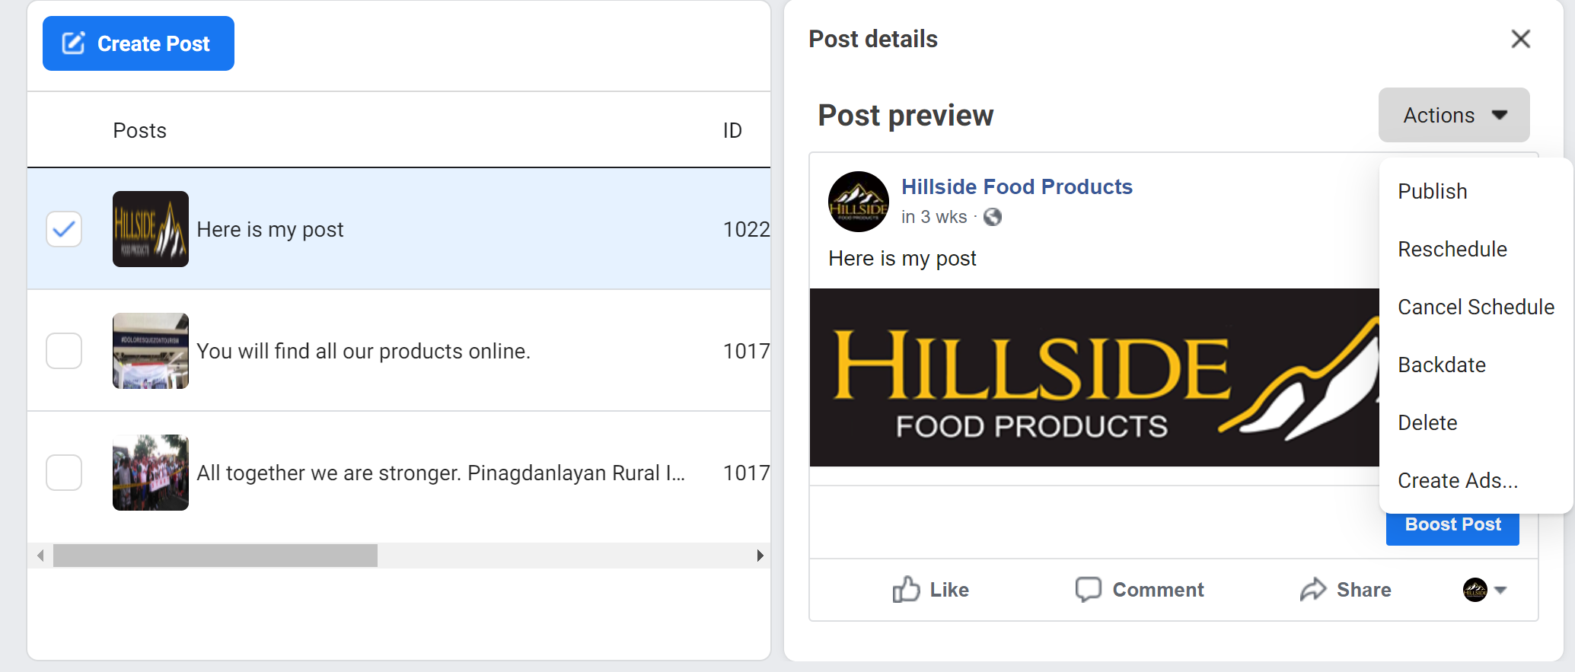
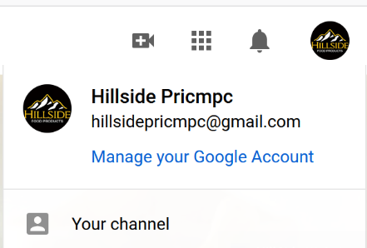

YouTube
To update your YouTube channel, first login with your Google account and go to youtube.com. On the right side, in your Google account, press Your Channel.
Go to Channel customization to modify the information about your channel and to Manage Videos to upload, schedule, see the statistics about your videos.

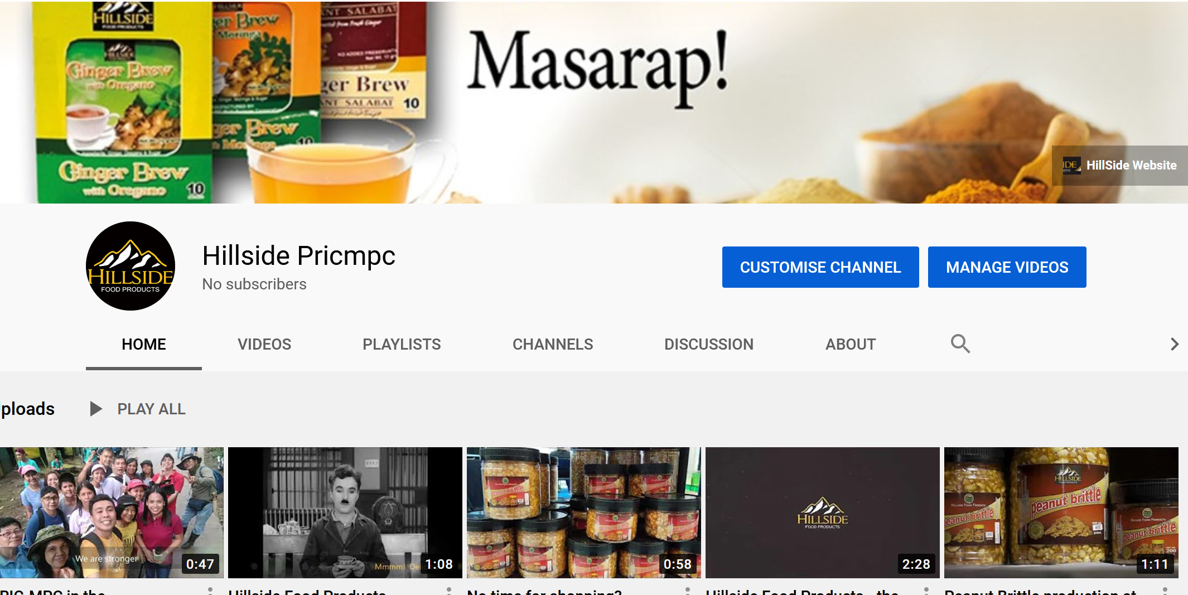
Upload video
Press Manage videos and use the menu content on your channel. Press Uploads. Once the video is uploaded it’s not available to the public. You will have to give some description and indicate the visibility to public.
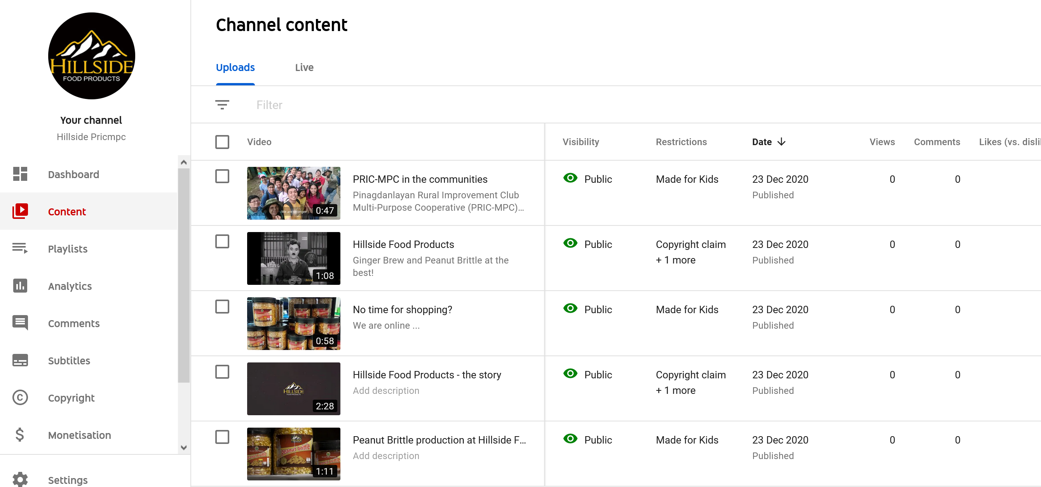
To update the content of your video or schedule the view, bring the mouse over the video and press the Edit button. This is where you will give the visibility and publish the video.
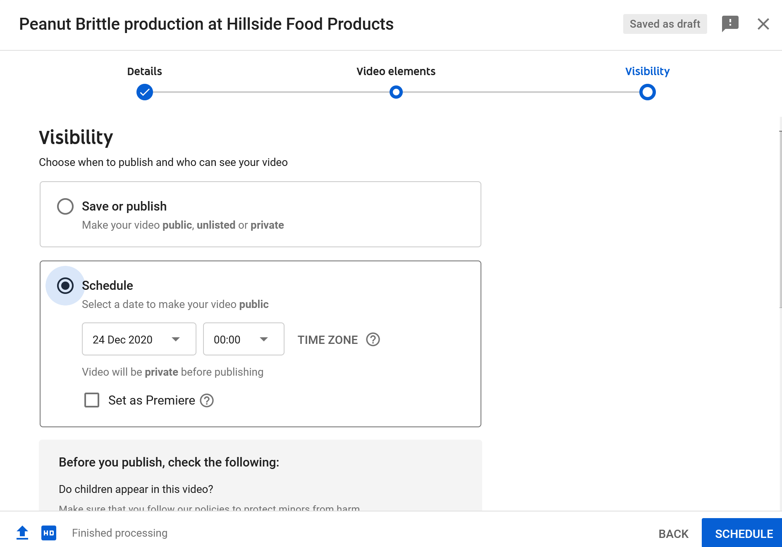

Website Maintenance
To keep WordPress working healthy, some site maintenance is required regularly. It’s a good practice to install the versions because it might improve your website and keep it secure. Plugins also have regular updates, new options.
I have set your site to update automatically. However, you should check your website regularly to see if everything is working correctly. Updates, like any software, can sometimes cause problems.
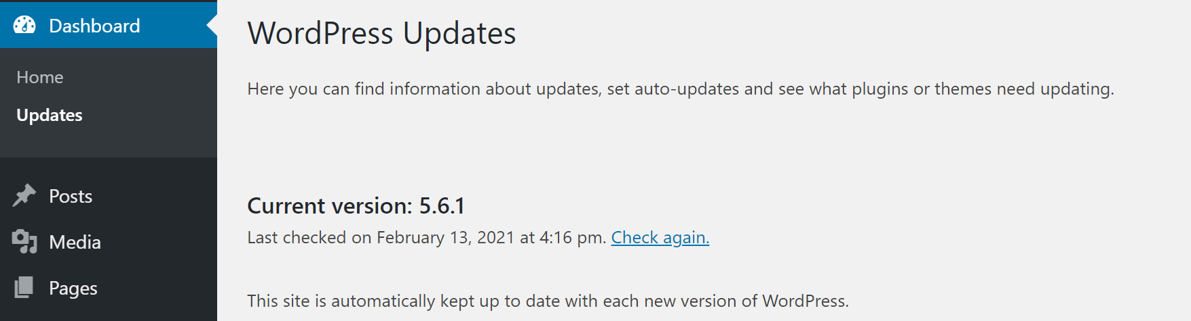
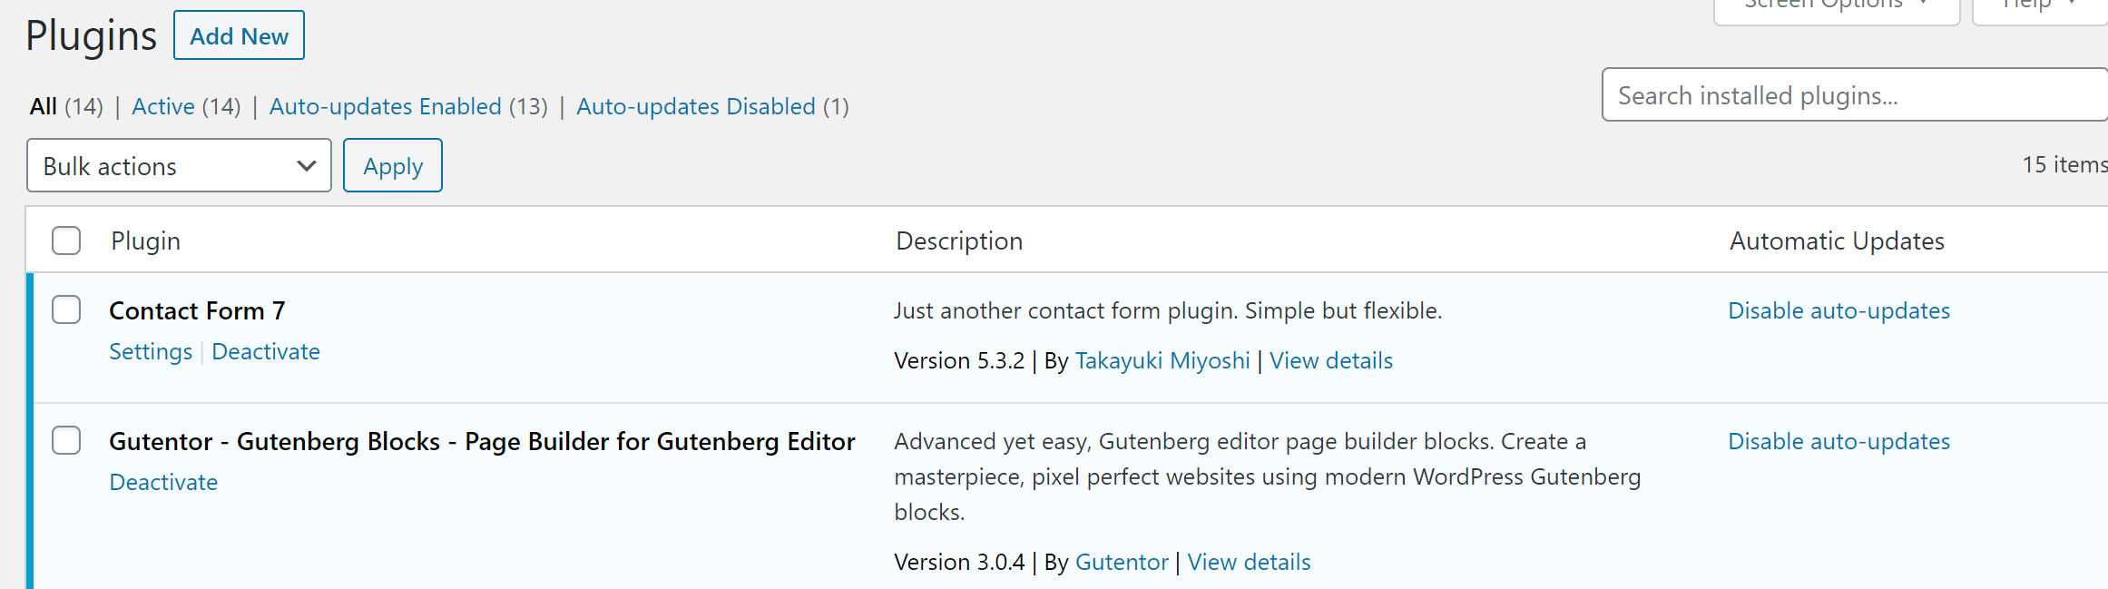

Appendix 1: Access

Gmail and Google Account
eMail : Password :

Hosting and Domain
Hostgator
https://portal.hostgator.com/login Code : Password :

Website WordPress
Each user will have his own code for administration but a general code have been created.
https://www.COMPANY.com/wp-admin Code : Password :

Google tools
In all the tools offered by Google to optimize the search engine, you must login in the Google account:
COMPANY@gmail.com password:
Measurement ID for Google Analytics =

Facebook
Account created under the name of Myla Arsenio with COMPANY@gmail.com (password)
The page is COMPANY and the link:
https://www.facebook.com/COMPANY

YouTube
Login first with your Google account. Go to youtube.com. Press Your channel or this link
https://www.youtube.com/channel/COMPANY

How to add another account to gmail
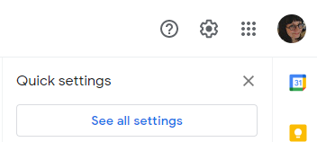
- In your computer, open Gmail.
- In the top right, click Settings See all settings.
- Click the Accounts and Import or Accounts tab.
- In the "Check mail from other accounts" section, click Add a mail account.
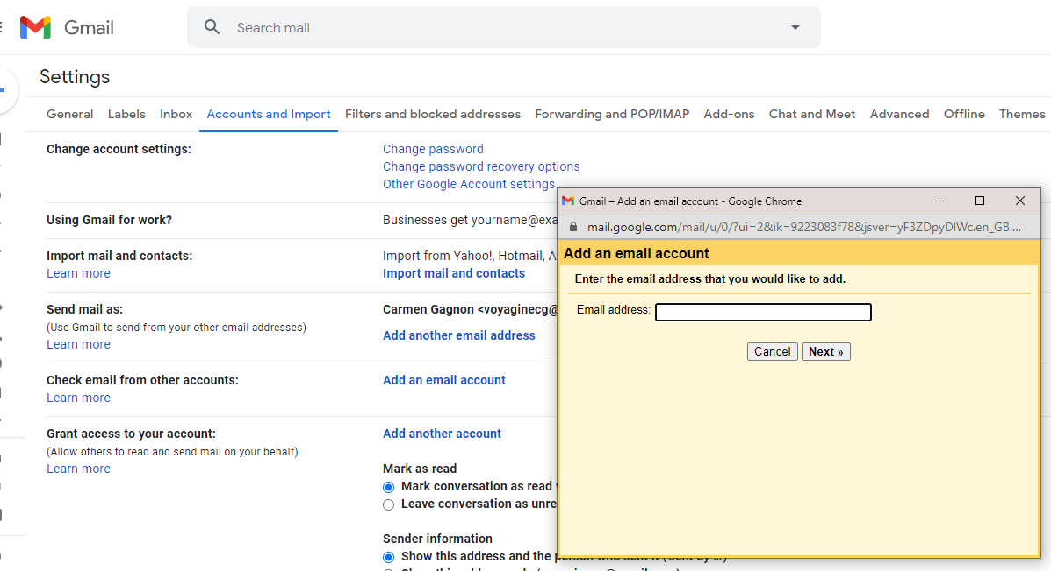
- Type the email address you want to link, then click Next.
- Select Link account with Gmail (Gmailify), then click Next.
- Follow the steps on the screen, then click Next or Sign in.
After you link your account, "Gmailify" will appear next to your email address. When you open Gmail, you’ll be able to read, reply to, and organize messages from your other account just like you do in Gmail.

